Annual Quality Assurance Report
(AQAR) – 2013-14

Submitted To

National Assessment and Accreditation Council (NAAC)

Submitted By

Aditya Institute of Technology and Management
(An Autonomous Institution)
Approved by AICTE, Permanently affiliated to JNTU, Kakinada
Accredited by NBA & NAAC, Recognised by UGC under 2(f), 12(b)
K.Kotturu (Vill), Tekkali, Srikakulam-Dist., A.P-532201
Website: www.adityatekkali.edu.in
Email: aditya_tekkali@yahoo.com

The Annual Quality Assurance Report (AQAR) of the IQAC

All NAAC accredited institutions will submit an annual self-reviewed progress report to NAAC, through its IQAC. The report is to detail the tangible results achieved in key areas, specifically identified by the institutional IQAC at the beginning of the academic year. The AQAR will detail the results of the perspective plan worked out by the IQAC.

Part – A

Aditya Institute of Technology and Management
1. Details of the Institution
1.1 Name of the Institution

K.Kotturu
1.2 Address Line 1

Tekkali
Address Line 2

Srikakulam
City/Town

Andhra Pradesh
State

532201
Pin Code
aditya_tekkali@yahoo.com

Institution e-mail address
9246657904, 9440195534

Contact Nos.
Prof. V.V. Nageswara Rao

Name of the Head of the Institution:
(+91) 8945-245666, 245266

Tel. No. with STD Code:

9246657904

Mobile:
Prof. Ch. Ramesh

Name of the IQAC Co-ordinator:
9247858288

Mobile:
iqac@adityatekkali.edu.in

IQAC e-mail address:
AITAM11471

1.3 NAAC Track ID

NAAC/A&AOC/EC-56/57/2011, Dated 16-09-2011
1.4 NAAC Executive Committee No. & Date:
(For Example EC/32/A&A/143 dated 3-5-2004.
This EC no. is available in the right corner-bottom
of your institution’s Accreditation Certificate)

www.adityatekkali.edu.in

1.5 Website address:
http://www.adityatekkali.edu.in/AQAR2013-14.doc

Web-link of the AQAR:

1.6 Accreditation Details
Sl. No. | Cycle | Grade | CGPA | Year of Accreditation | Validity Period
1 | 1st Cycle | B | 2.44 | 2011 | 16-09-2011 to 15-09-2016 (5 years)
2 | 2nd Cycle | - | - | - | -
3 | 3rd Cycle | - | - | - | -
4 | 4th Cycle | - | - | - | -

12/12/20011

1.7 Date of Establishment of IQAC: DD/MM/YYYY

2013-14

1.8 AQAR for the year (for example 2010-11)

1.9 Details of the previous year’s AQAR submitted to NAAC after the latest Assessment and Accreditation by NAAC
- AQAR 2011-12, 10-10-2014 (DD/MM/YYYY)
- AQAR 2012-13, 10-10-2014 (DD/MM/YYYY)
1.10 Institutional Status

University State Central Deemed Private
√

Affiliated College Yes No

Constituent College Yes No
√

Autonomous college of UGC Yes No

√
Regulatory Agency approved Institution Yes No
(eg. AICTE, BCI, MCI, PCI, NCI)
√

Type of Institution Co-education Men Women
√

Urban Rural Tribal

√
√

Financial Status Grant-in-aid UGC 2(f) UGC 12B
√

Grant-in-aid + Self Financing Totally Self-Financing

1.11 Type of Faculty/Programme

Arts Science Commerce Law PEI (Phys Edu)

√
TEI (Edu) Engineering Health Science Management

Others (Specify)

JNTUK, Kakinada

1.12 Name of the Affiliating University
(For the Colleges)

1.13 Special status conferred by Central/ State Government-- UGC/CSIR/DST/DBT/ICMR etc
University
Autonomy by State/Central Govt. / University
-
University with Potential for Excellence UGC-CPE
-
-
-
DST Star Scheme UGC-CE
-
-
UGC-Special Assistance Programme DST-FIST
-
-
UGC-Innovative PG programmes Any other (Specify)
-
UGC-COP Programmes
2. IQAC Composition and Activities
08
2.1 No. of Teachers
02
2.2 No. of Administrative/Technical staff
02
2.3 No. of students
2.4 No. of Management representatives
02
02
2.5 No. of Alumni
2.6 No. of any other stakeholder and
02
community representatives
2.7 No. of Employers/ Industrialists
01

2.8 No. of other External Experts
01
2.9 Total No. of members 20
20
2.10 No. of IQAC meetings held
03
02
05
2.11 No. of meetings with various stakeholder No. Faculty
01
01
01
Non-Teaching Staff Students Alumni Others
√
2.12 Has IQAC received any funding from UGC during the year? Yes No

-
If yes, mention the amount
2.13 Seminars and Conferences (only quality related)
(i) No. of Seminars/Conferences/ Workshops/Symposia organized by the IQAC
3

3
Total Nos. International National State Institution Level
Outcome Based Education

(ii) Themes

2.14 Significant Activities and contributions made by IQAC
- Academic auditing
- Orientation Program for Semester I students
- Encourages the research based work culture
- Faculties are encouraged to participate in seminars/conferences
- Modification of H.R policy guidelines
- Monitor the Progress and Financial status of the on-going projects

2.15 Plan of Action by IQAC/Outcome
The plan of action chalked out by the IQAC in the beginning of the year towards quality
enhancement and the outcome achieved by the end of the year *

Plan of Action | Achievements
- Makeup and Remedial classes  - Installing LCD projectors in all class rooms  - Organizing at least one national conference.  - Organizing at least one FDP in each departments  - To plan for Project Exhibition  - To plan for GATE coaching by college faculty to final year students  - Organizing workshops on outcome based education | - Several students were benefited  - LCD Projectors are procured and installed in all class rooms  - One National level conference is organized.  - Total 06 FDP’s are organized  - Increase students exposure to technical knowledge  - Total 25 students has been selected  - Two workshops on outcome based education were organized
* Academic Calendar (Annexure-II)

2.16 Whether the AQAR was placed in statutory body Yes No
√

√

Management Syndicate Any other body
Provide the details of the action taken
Institute demerits were identified. IQAC is suggested to overcome such demerits.

Part – B

Criterion – I

1. Curricular Aspects

1.1 Details about Academic Programmes
Level of the Programme | Number of existing Programmes | Number of programmes added during the year | Number of self-financing programmes | Number of value added / Career Oriented programmes
PhD | - | - | - | -
PG | 8 | - | 8 | -
UG | 7 | - | 7 | -
PG Diploma | - | - | - | -
Advanced Diploma | - | - | - | -
Diploma | 5 | - | 5 | -
Certificate | - | - | - | -
Others | - | - | - | -
Total | 20 | - | 20 | -

Interdisciplinary | - | - | - | -
Innovative | - | - | - | -

1.2 (i) Flexibility of the Curriculum: CBCS/Core/Elective option / Open options
(ii) Pattern of programmes:

Pattern | Number of programmes
Semester | 20
Trimester | -
Annual | -

√

√

√

√
1.3 Feedback from stakeholders* Alumni Parents Employers Students
(On all aspects)
√

√

Mode of feedback : Online Manual Co-operating schools (for PEI)
*Analysis of the feedback in the Annexure-I

1.4 Whether there is any revision/update of regulation or syllabi, if yes, mention their salient aspects.

-

1.5 Any new Department/Centre introduced during the year. If yes, give details.

No

Criterion – II
2. Teaching, Learning and Evaluation
Total | Asst. Professors | Associate Professors | Professors | Others
220 | 161 | 39 | 19 | 1
2.1 Total No. of permanent faculty
22
2.2 No. of permanent faculty with Ph.D.
Asst. Professors |  | Associate Professors |  | Professors |  | Others |  | Total
R | V | R | V | R | V | R | V | R | V
38 | - | 4 | - | 1 | - | 2 | - | 45 | -
2.3 No. of Faculty Positions Recruited (R) and Vacant (V) during the year
15

2.4 No. of Guest and Visiting faculty and Temporary faculty

2.5 Faculty participation in conferences and symposia:

No. of Faculty | International level | National level | State level
Attended  Seminars/ Workshops | 17 | 24 | 3
Presented papers | 12 | 13 | -
Resource Persons | 1 | - | -

2.6 Innovative processes adopted by the institution in Teaching and Learning:

- Curriculum and syllabus updation based on Outcome Based Education.
- Use of e-learning resources.
- Recognition to innovative and creative contributions of faculty and students.
- Sharing the experiences of experts in the form of guest lecturers and practical demonstrations.
- Digital Courseware
- Active Learning laboratory
- Conducting Online tests
- LCD’s arranged in all the classrooms

2.7 Total No. of actual teaching days
192
during this academic year
- Single valuation system-valuation outside the campus (for autonomous stream)
- As per University rules (for JNTUK stream)
2.8 Examination/ Evaluation Reforms initiated by
the Institution (for example: Open Book
Examination, Bar Coding, Double Valuation,
Photocopy, Online Multiple Choice Questions)

71
2.9 No. of faculty members involved in curriculum
restructuring /revision/syllabus development as
member of Board of study/Faculty/Curriculum
Development workshop
82.51%
2.10 Average percentage of attendance of students

2.11 Course/Programme wise distribution of pass percentage:

Title of the Programme | Total no of students appeared | Division
 |  | Distinction % | I % | II % | III % | Pass %
B. Tech
Electronic & Communication Engineering | 134 | 44.56 | 45.54 | 9.90 | - | 75.37
Computer Science & Engineering | 120 | 40.59 | 46.54 | 12.87 | - | 84.16
Electrical & Electronics Engineering | 122 | 44.12 | 50.98 | 4.9 | - | 83.6
Mechanical Engineering | 72 | 23.08 | 35.38 | 35.38 | 6.16 | 90.3
Information Technology | 53 | 22.86 | 71.43 | 5.71 | - | 68.62
Civil Engineering | - | - | - | - | - | -
Applied Electronics & Instrumentation Engineering | 52 | 22.58 | 67.75 | 9.67 | - | 59.61
Master of Business Administration | 53 | 15 | 75 | 10 | - | 100
Master of Computer Applications | 21 | 84.22 | 15.78 | - | - | 90.47
M. Tech
Computer Science & Engineering (CSE) | 30 | 92.59 | 7.41 | - | - | 90
VLSI System Design (ECE) | 16 | 75 | 25 | - | - | 100
Information Technology (IT) | 3 | 100 | - | - | - | 100
Power Electronics & Drives (EEE) | 24 | 66.67 | 33.33 | - | - | 75
Digital Electronics & Communication Systems (ECE) | 07 | 100 | - | - | - | 100
Thermal Engineering (ME) | 18 | 62.5 | 37.5 | - | - | 44.44

2.12 How does IQAC Contribute/Monitor/Evaluate the Teaching & Learning processes:
- Attainment of course outcomes and mapping of course outcomes with program outcomes are evaluated by the Academic Audit Cell.
- Improvement in teaching and learning processes is monitored by academic advisory committee.
2.13 Initiatives undertaken towards faculty development
Faculty / Staff Development Programmes | Number of faculty  benefitted
Refresher courses | 3
UGC – Faculty Improvement Programme | 1
HRD programmes | 3
Orientation programmes | -
Faculty exchange programme | 3
Staff training conducted by the university | 5
Staff training conducted by other institutions | 3
Summer / Winter schools, Workshops, etc. | 74
Others | -
2.14 Details of Administrative and Technical staff
Category | Number of Permanent  Employees | Number of Vacant  Positions | Number of permanent positions filled during the Year | Number of positions filled temporarily
Administrative Staff | 74 | - | 2 | -
Technical Staff | 62 | - | 9 | -

Criterion – III
3. Research, Consultancy and Extension
3.1 Initiatives of the IQAC in Sensitizing/Promoting Research Climate in the institution
- Faculties are encouraged by providing incentives for research papers publications in journals
- Addressing about various research schemes through Research and Development cell

3.2 Details regarding major projects
 | Completed | Ongoing | Sanctioned | Submitted
Number | - | 2 | 1 | 9
Outlay in Rs. Lakhs | - | 25,77,135 | 10,85,000 | 1,32,76,280

3.3 Details regarding minor projects
 | Completed | Ongoing | Sanctioned | Submitted
Number | - | - | - | -
Outlay in Rs. Lakhs | - | - | - | -

3.4 Details on research publications
 | International | National | Others
Peer Review Journals | 118 | 7 | -
Non-Peer Review Journals | 14 | 0 | -
e-Journals | 0 | 0 | -
Conference proceedings | 19 | 16 | -

3.5 Details on Impact factor of publications:
1.75

Range Average h-index Nos. In SCOPUS
3.6 Research funds sanctioned and received from various funding agencies, industry and other organisations
Nature of the Project | Duration  Year | Name of the  funding Agency | Total grant  sanctioned | Received
Major projects | 3 | DST | 10,85,000 | 4,00,000
 | 2 | DST | 14,92,135 | 4,00,000
Minor Projects | - | - | - | -
Interdisciplinary Projects | - | - | - | -
Industry sponsored | - | - | - | -
Projects sponsored by the University/ College | - | - | - | -
Students research projects (other than compulsory by the University) | - | - | - | -
Any other (Specify) | - | AICTE  (1 year) | 15,25,000 | 10,80,000
 |  | DST (21days) | 10,00,000 | 5,00,000
Total | - | - | 51,02,135 | 23,80,000

04
3.7 No. of books published i) With ISBN No. Chapters in Edited Books

ii) Without ISBN No.

3.8 No. of University Departments receiving funds from
-
-
-
UGC-SAP CAS DST-FIST
-
-
DPE DBT Scheme/funds
3.9 For colleges Autonomy CPE DBT Star Scheme
-
-
-
INSPIRE CE Any Other (specify)
-
-
-

3.10 Revenue generated through consultancy
2,00,000/-

3.11 No. of conferences Organized by the Institution
Level | International | National | State | University | College
Number | - | 01 | - | - | -
Sponsoring Agencies | - | TEQIP | - | - | -

22
3.12 No. of faculty served as experts, chairpersons or resource persons
3.13 No. of collaborations International National Any other
-
-
02
-
3.14 No. of linkages created during this year
3.15 Total budget for research for current year in lakhs:
1,36,000/-
22,60,000/-
From funding agency From Management of University/College
Total
23,96,000/-

3.16 No. of patents received this year
Type of Patent |  | Number
National | Applied | -
 | Granted | -
International | Applied | -
 | Granted | -
Commercialised | Applied | -
 | Granted | -

3.17 No. of research awards/ recognitions received by faculty and research fellows of the
institute in the year

Total | International | National | State | University | Dist | College
- | - | - | - | - | - | -

3.18 No. of faculty from the Institution
03
who are Ph. D. Guides
05
and students registered under them
-08
3.19 No. of Ph.D. awarded by faculty from the Institution

3.20 No. of Research scholars receiving the Fellowships (Newly enrolled + existing ones)
-
-
JRF SRF Project Fellows Any other
-
-
3.21 No. of students Participated in NSS events:
100
-
University level State level
-
National level International level
-
3.22 No. of students participated in NCC events:
-
-
University level State level
National level International level
-
-
3.23 No. of Awards won in NSS:
-
-
University level State level
National level International level
-
-
3.24 No. of Awards won in NCC:
-
-
University level State level
-
-
National level International level
3.25 No. of Extension Activities Organized
-
-
University forum College forum
-
8
-
NCC NSS Any other
3.26 Major Activities during the year in the sphere of extension activities and Institutional Social Responsibility
- NSS Annual camp.
- Adoption of Village (Adult Education, AIDS Sanitation Awareness, Save Girl Child Campaign, School Campus beautification)
- Blood Donation Camp
- Tree Sampling Programme
- Engineers Day Celebrations
- Teachers Day Celebrations
- Women’s Day Celebrations

Criterion – IV

4. Infrastructure and Learning Resources
4.1 Details of increase in infrastructure facilities:
Facilities | Existing | Newly Created | Source of Fund | Total
Campus area | 25.60 Acres | - | Self | 25.60 Acres
Class rooms | 67 | - | - | 67
Laboratories | 48 | 1 | - | 49
Seminar Halls | 4 | - | - | 4
No. of important equipments purchased (≥ 1-0 lakh) during the current year. | 3 | 1 | - | 4
Value of the equipment purchased during the year (Rs. In Lakhs) | 13,60,000 | 6,40,500 | AICTE Modrobs (13 laks) | 20,00,500
Others | - | - | - | -

4.2 Computerization of Administration and Library

- Use of OPAC software in library.
- Use of computers and data storage in all administration & library sections.
- Use of Tally software for account maintenance.
- Library is computerized. Issue & Collection through BAR Code System.

4.3 Library services:
 | Existing |  | Newly added |  | Total
 | No. | Value | No. | Value | No. | Value
Text Books | 1232 | 4,18,599/- | 231 | 88,955/- | 1463 | 5,07,554/-
Reference Books | 600 | 2,04,000/- | 18 | 7,020/- | 618 | 2,11,020/-
e-Books |  |  | - | - | - | -
Journals | 63 | 88,453/- | - | - | 63 | 88,453/-
e-Journals | 145 | 3,73,920/- | - | - | 145 | 3,73,920/-
Digital Database | - | - | - | - | - | -
CD & Video | - | - | - | - | - | -
Others (specify) | - | - | - | - | - | -
4.4 Technology up gradation (overall)
 | Total Computers | Computer Labs | Internet | Browsing Centres | Computer Centres | Office | Depts. | Others
Existing | 1089 | 22 | 30 Mbps | 02 | 22 | 11 | 56 | 09
Added | 05 | - | - | - | - | - | - | -
Total | 1094 | 22 | 30 Mbps | 02 | 22 | 11 | 56 | 09

4.5 Computer, Internet access, training to teachers and students and any other programme for technology up gradation (Networking, e-Governance etc.)

- Adequate computer access to faculty / staff / students
- Training to faculty / staff / students on ICT
- Wi-Fi enabled campus

4.6 Amount spent on maintenance in lakhs :
29.89
i) ICT
109.53
ii) Campus Infrastructure and facilities

iii) Equipments
42.18
58.68
iv) Others
240.28
Total :

Criterion – V

5. Student Support and Progression
5.1 Contribution of IQAC in enhancing awareness about Student Support Services
- Training & Placement assistance through alumni.
- Gate coaching.
- Provision of Hi-tech Gym.
- Health centre facility.
- Scholarship for academically excellent & financially poor students
- Grievance Redressal Cell
- Arrangement of Industrial visit to enhance practical knowledge.

5.2 Efforts made by the institution for tracking the progression
- Conduct career development programs for students.
- Following transparent admission procedure.
- Highlighting achievements of students in college news letter.
- Making college bus facility available on field visits.
- Making parents meet and informing them on the progress of their children.
- A mentor is allocated for a batch of 20 students in each programme to monitor and counsel the students’ progress in academic as well as extra-curricular activities.

UG | PG | Ph. D. | Others
2782 | 335 | - | -

5.3 (a) Total Number of students

(b) No. of students outside the state
37
50
(c) No. of international students

No | %
2014 | 64.61
No | %
1103 | 35.39
Men Women
Last Year |  |  |  |  |  | This Year
General | SC | ST | OBC | Physically Challenged | Total | General | SC | ST | OBC | Physically Challenged | Total
806 | 258 | 53 | 1882 | - | 2999 | 834 | 225 | 49 | 2009 | - | 3117

Demand ratio: - Dropout %: 0.67

5.4 Details of student support mechanism for coaching for competitive examinations (If any)
- Curriculum itself covers the syllabus contents of competitive examinations.
- Examination pattern includes MCQs
- Training on aptitude / quantitative / communication aspects through mandatory personality developed courses embedded in the curriculum.
- Comprehension courses mirroring the competitive examination syllabus

70
No. of students beneficiaries
5.5 No. of students qualified in these examinations
-
-
22
-
NET SET/SLET GATE CAT
IAS/IPS etc State PSC UPSC Others
-
-
-
-

5.6 Details of student counselling and career guidance
- Counseling and career guidance programs promote the personal, social, educational, and career development of students
- Student mentor system to counsel and guide the students.
- Faculty Counsellor is appointed for every 20-30 students
- The strength and weakness of each student is identified through counseling.
- Students are given guidance to use their strength and overcome the weakness.
- Career guidance cell functions to tap the potentiality in students which help them to take up the profession of their interest.
- Technical orientation programme for I year students.
- Aptitude Training Programme to enhance the problem solving skills of students
- GATE coaching for student’s higher studies
- Professional (Psychiatry) counselling by full time doctors.
All the students
No. of students benefitted

5.7 Details of campus placement
On campus |  |  | Off Campus
Number of Organizations Visited | Number of Students Participated | Number of Students Placed | Number of Students Placed
15 | 1200 (approximate) | 168 | 24

5.8 Details of Gender Sensitization Programmes
Women Grievances Redressal cell is activated and it functions separately for the welfare of the girls students and lady faculties and staff.

5.9 Students Activities
5.9.1 No. of students participated in Sports, Games and other events
-
-
12
State/ University level National level International level

No. of students participated in cultural events
-
-
-
State/ University level National level International level

5.9.2 No. of medals /awards won by students in Sports, Games and other events
4
-
-
Sports: State/ University level National level International level
-
-
-
Cultural: State/ University level National level International level

5.10 Scholarships and Financial Support
 | Number of  Students | Amount
Financial support from institution | 571 | 1,07,77,200/-
Financial support from government | 1571 | 6,76,28,900/-
Financial support from other sources | - | -
Number of students who received International/ National recognitions | - | -
5.11 Student Organised / Initiatives
02
-
-
Fairs : State/ University level National level International level
02
-
-
Exhibition: State/ University level National level International level

5.12 No. of social initiatives undertaken by the students

5.13 Major grievances of students (if any) redressed:

College has a suggestion box to address the suggestions of students. It is opened every Friday and follow-up actions are taken immediately. There is no suggestion about any major problem but sometimes students complain against the poor sanitary conditions.

Criterion – VI
6. Governance, Leadership and Management
6.1 State the Vision and Mission of the institution
VISION

TO EVOLVE INTO A PREMIER ENGINEERING INSTITUTE IN THE COUNTRY BY CONTINUOUSLY ENHANCING RANGE OF OUR COMPETENCIES, EXPANDING THE GAMUT OF OUR ACTIVITIES AND EXTENDING THE FRONTIERS OF OUR OPERATIONS.

MISSION

SYNERGIZING KNOWLEDGE, TECHNOLOGY, AND HUMAN RESOURCE, WE IMPART BEST QUALITY EDUCATION IN TECHNOLOGY AND MANAGEMENT. IN THE PROCESS, WE MAKE EDUCATION MORE OBJECTIVE SO THAT EFFICIENCY FOR EMPLOYABILITY INCREASES ON A CONTINUED BASIS.

6.2 Does the Institution has a management Information System
Yes. The institution has a management information system.

6.3 Quality improvement strategies adopted by the institution for each of the following:
6.3.1 Curriculum Development
- Student Feedback
- Outcome Based Education
- External Experts from Industry and Institutes in Board of Studies
- Curriculum Revision to meet the Industry Demands.
- Input from Industrial Advisory / International Advisory Boards.

6.3.2 Teaching and Learning
- Implementation of Outcome Based Education.
- Defining course outcomes to meet program outcomes.
- Identifying content delivery method.
- Assessing the students using various evaluation techniques for the attainment of course outcomes.
- Guest Lecturers
- Field trips and Lab Lectures.
- Mentoring
- Tutorial Teaching
- Mapping Student Outcomes / Instructional Objectives and Program Educational Objectives
- Uploading Lesson Plan / Question Paper Keys
- Use of Internet, PPT Presentation during class room teaching.

6.3.3 Examination and Evaluation
- All components in any programme of study are evaluated continuously through internal evaluation and an external evaluation. Internal evaluation is done throughout semester in the form of mid examinations and assignments. External evaluation is done at the end of semester in the form of end examination.
- Question paper setters for end examination are from outside the college. Evaluation of answer scripts will be done by the external examiners from other colleges and universities.
- The method of evaluation involves coding & decoding of answer scripts to ensure unbiased evaluation. Evaluation process is transparent. Institute communicates the outcome of the evaluation by publishing results on the internet through Institute website.
- Students are permitted to request for recounting/ revaluation of the end theory examination answer scripts within a stipulated period after announcement of the results.
- After recounting or revaluation, records are updated with changes if any and the student will be issued a revised memorandum of marks. If there are no changes, the student shall be intimated the same through a letter or a notice.
- Based on the credits and marks obtained by the student semester grade point Average (SGPA) will be calculated for semester and Cumulative grade Point Average (CGPA) will be calculated for entire program. Award of class will be finalized based on CGPA.

6.3.4 Research and Development
- Three programs( ECE,CSE,ME ) having research centres approved by JNTUK University
- Research committee has been constituted for inculcating research atmosphere and to review the progress of research activities in the campus
- Incentives for research publications and research projects are provided.
- Funded Projects by Industries / Government Departments / Industries
- Publication in peer reviewed journals
- Incentives for faculty for publishing papers / getting funded projects
- Special incentives for faculty holding Ph. D degrees
- Sponsorship to present papers in / attend international / national conferences.

6.3.5 Library, ICT and physical infrastructure / instrumentation
- Fully automated, well stocked, air-conditioned central library.
- Student records / attendance / internal marks / fee payments / fully computerised.
- Correspondence through e-mails
- Purchase / salary / leave records of faculty / applying leave etc., fully computerised.
- Wi-Fi enabled campus

6.3.6 Human Resource Management
- In the institution, the process of assessing adequate human power requirements, staff recruiting, monitoring and planning professional development programmes for personnel development and seeking appropriate feedback responses are very good.
- Recruitment of faculty and staff are based on the guidelines provided by JNTUK, Kakinada and AICTE, New Delhi.
- There are many staff welfare schemes namely EPF, Group Insurance and Salary advances, Transport facility.
- Sponsorship for Higher Studies for Faculties
- Organizing Developmental Training programme and workshop / seminars for enhancing the multi-skills of faculties.
- Incentives are given to the faculties for their contribution in research.
- Effective appraisal system has been followed to assess the performance of faculties.
- Well laid policy for recruitment / upward mobility
- Organization of in-house faculty development programs.

6.3.7 Faculty and Staff recruitment
- Releasing the advertisement in the Leading daily newspapers.
- Online submission of resume
- Scrutinizing of Application as per the college norms.
- Conducting Interviews in the presence of External Experts and University Nominees.
- Selection of Candidates as per the norms of staff selection committee.

6.3.8 Industry Interaction / Collaboration
- A dedicated Institute Industry Interaction Cell (IIIC).
- Collaborative MoUs with 33 industries

6.3.9 Admission of Students
- A candidate should possess the eligibility of 10+2 qualification with MPC group from Board of Intermediate, Government of Andhra Pradesh or any other equivalent examination recognized as equivalent there to.
- A student to step in four-year degree course in Engineering except NRI quota must qualify in "Engineering, Agricultural Sciences and Medical Common Entrance Test" (EAMCET), a State-Level Entrance Test conducted by the Govt. of Andhra Pradesh. Students who qualify in EAMCET entrance test will be admitted strictly on merit bases.
- The Convener of EAMCET admits on merit secured in Intermediate or an equivalent examination and the rank secured in EAMCET.
- The Management admits candidates for the Management and NRI quota based on merit and should possess first class in Subjects: Mathematics, Physics, and Chemistry.
- The Convener of ECET admits 20% of the candidates from the stream of Diploma Holders should pass in diploma from Andhra Pradesh State Government or an equivalent examination.
- Similarly PG student joins based on PGCET & ICET’s

Teaching | Transport Facilities, Medical and Maternity Leave, EPF,  Group Insurance
Non teaching | Transport Facilities, Medical and Maternity Leave, EPF, Group Insurance
Students | NSS, ISTE Chapter
6.4 Welfare schemes for

NIL
6.5 Total corpus fund generated

√

6.6 Whether annual financial audit has been done Yes No

6.7 Whether Academic and Administrative Audit (AAA) has been done?
Audit Type | External |  | Internal
 | Yes/No | Agency | Yes/No | Agency
Academic | No | - | Yes | Academic Auditing Committee Headed by Professor
Administrative | No | - | No | -

6.8 Does the University/ Autonomous College declare results within 30 days?
√

For UG Programmes Yes No
√

For PG Programmes Yes No

6.9 What efforts are made by the University/ Autonomous College for Examination Reforms?
- End examination question paper setters are from other colleges and universities.
- Examiners for end examinations are from other colleges and universities.
- Evaluation process involves coding & decoding of answer scripts.
- Recounting and revaluation facility is provided to student.
- Award of class will be finalized based on CGPA.

6.10 What efforts are made by the University to promote autonomy in the affiliated / constituent colleges?
The JNTUK University effort to bring the autonomous status for AITAM is:

- To promote academic freedom in autonomous colleges by encouraging introduction of innovative academic programmes
- To facilitate new courses of study, subject to the required minimum number of hours of instruction, content and standards
- To permit them to issue their own semester wise mark sheets, provisional’s.
- To reduce work effort by university people and with depute various nominees of the university to serve in various committees of the autonomous colleges and get the feedback on their functioning
- To provide academic flexibility to the institute

6.11 Activities and support from the Alumni Association
An alumni meeting is conducted every year. They regularly interact with the students to create awareness about an industry environment. Guest lecturers are also arranged for more awareness on industry.

6.12 Activities and support from the Parent – Teacher Association
PTA meeting is conducted twice in a year. Suggestions are received from the parents for the improvement of the institution. Also the difficulties faced by the students are got and they are rectified before the next PTA meeting. According to the parents’ suggestion in last year PTA meeting, the students are given training programmes to improve their communication.

6.13 Development programmes for support staff
- Incentives for Higher Studies
- Absorption in teaching cadre once they acquire requisite qualification and if found suitable
- Language Training
- Technical Training

6.14 Initiatives taken by the institution to make the campus eco-friendly
- The College has a green campus and peace ambience with sylvan surroundings
- Campus is completely pollution free
- Every year new saplings are added to greenish the campus
- Tree Plantation
- Minimizing Water Wastage
- Rainwater Harvesting
- Minimising use paper

Criterion – VII
7. Innovations and Best Practices
7.1 Innovations introduced during this academic year which have created a positive
impact on the functioning of the institution. Give details.

- Introduced Outcome Based Education
- Faculties are insisted to identify the best content delivery methods to attain Programme Outcomes through Course Outcomes
- Faculties are requested to identify the best assessment tools to evaluate the performance of students in attaining Course Outcomes
- Autonomous status of the Institution enables to introduce an industry oriented technology in the syllabus so as to enable the graduates to face challenges in the future career.

7.2 Provide the Action Taken Report (ATR) based on the plan of action decided upon at
the beginning of the year

IQAC planned the objectives for current year (2013-14) and its progress was monitored through action taken report monthly from all concerned persons. In its meeting these action taken reports were discussed and correction was done appropriately whenever it was required

7.3 Give two Best Practices of the institution (please see the format in the NAAC Self-study Manuals)
- Placement Cell and Career Counselling
- Remedial Classes

* Details in Annexure-III

7.4 Contribution to environmental awareness / protection
- AITAM seeks to provide an education combining the generous arts, work and service with a strong commitment to environmental responsibility and cross-cultural understanding in a setting that promotes wisdom, spiritual growth and contribution to the common good.
- AITAM demonstrate its strong commitment to environmental responsibility through these commitments:
- Within the limits of practical considerations to conserve energy and resources, reduce waste, purchase environmentally friendly products, and minimize our adverse impact on the surrounding environment.
- Recognize and promote efforts to increase a deep, aesthetic, spiritually based awareness of our connection to the environment among the students of this institute and the larger community.
- Every year 25-50 trees are planted in the campus
√

7.5 Whether environmental audit was conducted? Yes No

7.6 Any other relevant information the institution wishes to add. (for example SWOT Analysis)
Strengths:
  - AITAM imparts quality technical education for students hailing from backward district, Srikakulam and rural north coastal areas of Andhra Pradesh since 2001 for their social up-liftment.
  - AITAM is an AICTE approved and NBA accredited college in the Srikakulam district where consistently most of the seats are filled-up by brand image and confidence of parents.
  - AITAM’s management commitment, transparent policies, incentives/rewards schemes and professional and personal growth opportunities for well rated faculty helped in 95% faculty retention for last five years.
  - AITAM’s unique selling points are very good physical infrastructure with more than 3,80,000 sq ft built-up area, well equipped laboratories, air conditioned digital library, computing facilities with networking, web based information system, Wi-Fi campus and committed faculty members who are young, dynamic and quality conscious.
  - Highly motivated faculty with strong work ethics and commitment for quality teaching results in five students securing University ranks in 2009.
  - In-house placement and training programs, career guidance from 2nd year onwards help students in getting good placements in industries.
  - Entrepreneurship Development cell provides special attention to develop Entrepreneurship skills to mould students to become Entrepreneurs and also provides support to local Entrepreneurs.
  - AITAM’s willingness to recognize weaknesses and make improvement for atmosphere of success for students, faculty and staff is its uniqueness.
  - Recent birth of research culture in the institute and Industry institute interaction encourages for better services to students and faculty.

Weaknesses:
- Many faculty members have limited industrial and research experience.
- Not many number of senior faculty members have Ph.D. qualification.
- Culture for Research, Development and Consultancy activities have just taken roots recently resulting in less number of publications and no patents.
- Students from rural areas with poor communication skills, less motivation and the spoon-fed culture always require special attention to increase the employability of graduates.
- Graduating students have little experience on real-time design projects, exposure to industrial applications lead to low learning outcome of the students.
- Smart class rooms and modern auditorium is not yet functional.
- Only three UG programs are accredited by NBA and no PG Programme accredited by NBA.
- Less interaction and networking with reputed institutes & Industries.
- Limited budget allocation for faculty and staff development programmes and also to organize international/national workshops, seminars and conferences.
- Low Academic performance of SC, ST, OBC students need special attention.
Opportunities:
- Growing rural industrialization (Thermal power plants, Software Park at Visakhapatnam etc.) in the region may provide good employment potential to our college students.
- Strategic focus on to start and develop high demand and need-based PG and certification programmes after autonomous status.
- Possibility of utilizing Local, regional and National development opportunities in emerging sectors for teaching, research and consultancy.
- Young and dynamic society is a good pool for potential students and parents who are ready to accept changes.
- Visakhapatnam as a fast developing industrial city is close (140 KMs only) to Tekkali to get better Employment opportunities.
- Increase and strength internal and external collaborations with other educational institutions and industries.
- Possibility to increase external revenue through short term courses, testing services, training in appropriate technology suitable to this region.
- Possibility of improvement in overall progress of the institute after autonomous status.
- Possibility of MOUs with reputed institutes like IIT, NIT and Industries in India and abroad.

Threats:
- Emerging competition from local, regional and global private, government institutions and Universities.
- Fast pace of developments in technology and emerging new fields leading to more challenges.
- Limited availability of quality teaching faculty in engineering education.
- Fluctuating job market in the country and abroad.
- Quality of incoming students (Language, analytical, thinking, motivation) in future.

8. Plans of institution for next year
- Faculties shall be encouraged to involve in R&D and Consultancy activities.
- Faculties shall be encouraged to publish papers in high quality journals
- Faculties shall be encouraged to participate more in the National / International Conferences, Workshops and Seminars etc.
- To conduct International Conferences.
- Faculties shall be encouraged to pursue higher studies Ph.D etc.,
- To conduct staff development programmes for non-teaching staff.
- To complete the pending infrastructural works in the campus.
- To make the students’ industry ready by imparting different skill based training apart from their course curriculum.
- To enhance the job opportunity by attracting more good companies

Name : Prof. Ch. Ramesh Name: Prof. V.V. Nageswara Rao
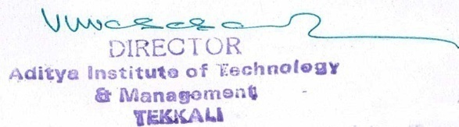
_______________________________

Signature of the Coordinator, IQAC Signature of the Chairperson, IQAC

_______***_______
Annexure I

Abbreviations:
CAS - Career Advanced Scheme
CAT - Common Admission Test
CBCS - Choice Based Credit System
CE - Centre for Excellence
COP - Career Oriented Programme
CPE - College with Potential for Excellence
DPE - Department with Potential for Excellence
GATE - Graduate Aptitude Test
NET - National Eligibility Test
PEI - Physical Education Institution
SAP - Special Assistance Programme
SF - Self Financing
SLET - State Level Eligibility Test
TEI - Teacher Education Institution
UPE - University with Potential Excellence
UPSC - Union Public Service Commission

***************

Annexure-I

Feedback Questions
  - Theory:

- Teacher comes to class on time
- Teaching is well planned
- Teacher makes objectives clear
- Subject matters are organized in logical sequence
- Teacher comes well prepared in the subject
- Teacher speaks clearly and audibly
- Teacher writes and draws visibly
- Teacher explains with examples clearly
- Teaching pace is good, not very fast
- Teacher offers assistance and counseling.
- Teacher asks relevant questions for interaction
- Teacher encourages raising doubts
- Teacher ensures learning of subject
- Teacher encourages originality and creativity
- Teacher is courtesies and impartial
- Teacher is regular and maintains discipline
- Teacher covers the syllabus at appropriate pace
- Teacher holds quizzes, seminars regularly
- Teacher correction of scripts is fair and impartial
- Faculty uploading their course material in E-Portal or not.

  - Labs:
- Are you satisfied with your batch Size?
- Are the experiments of the Lab Classes conducted as per schedule provided?
- Are the Equipment’s provided sufficient?
- Are the Equipment’s provided in working condition?
- Are the Lab Consumables provided of Good Quality?
- Are the experiments were conducted over and Above the Syllabus?
- The Lab Manual Provided was complete in covering the Syllabus and informative
- Whether the lab assistant/technician are assisting you
- Whether the lab in-charges (Faculties) are helpful in the Lab

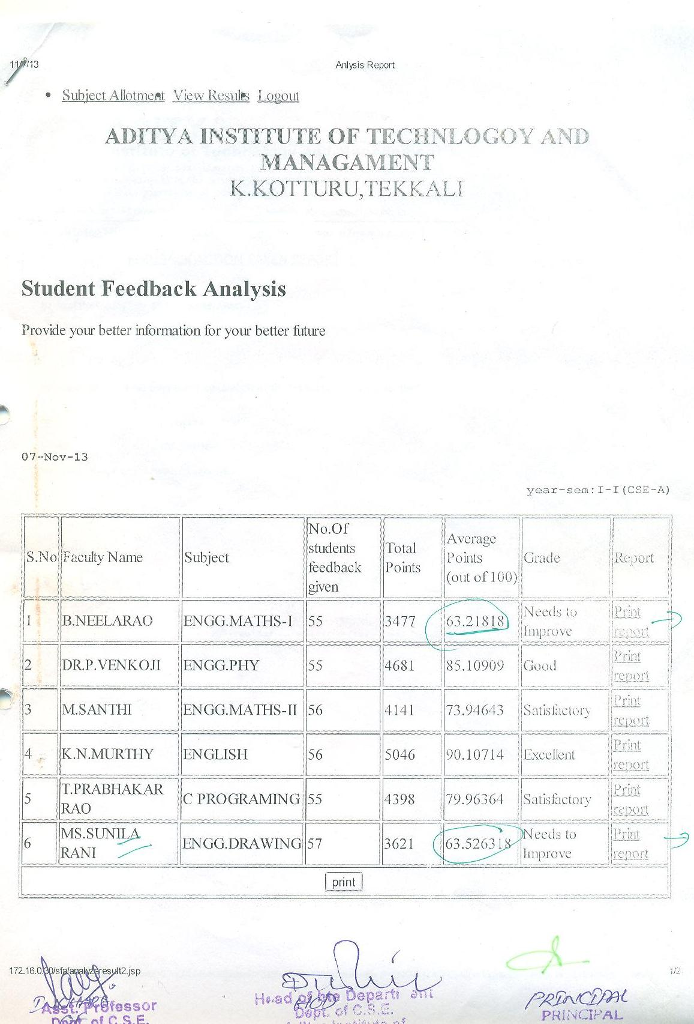
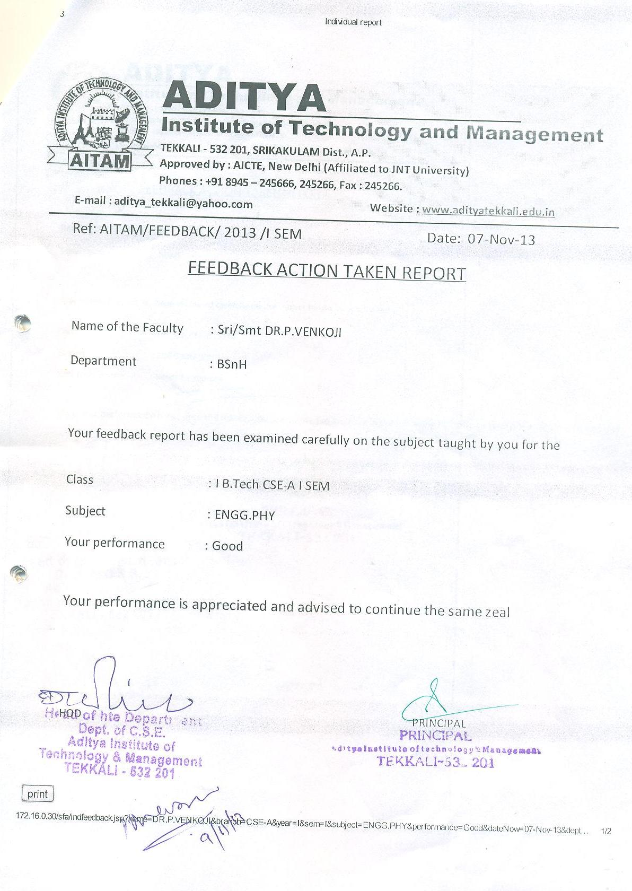

Alumni Feedback

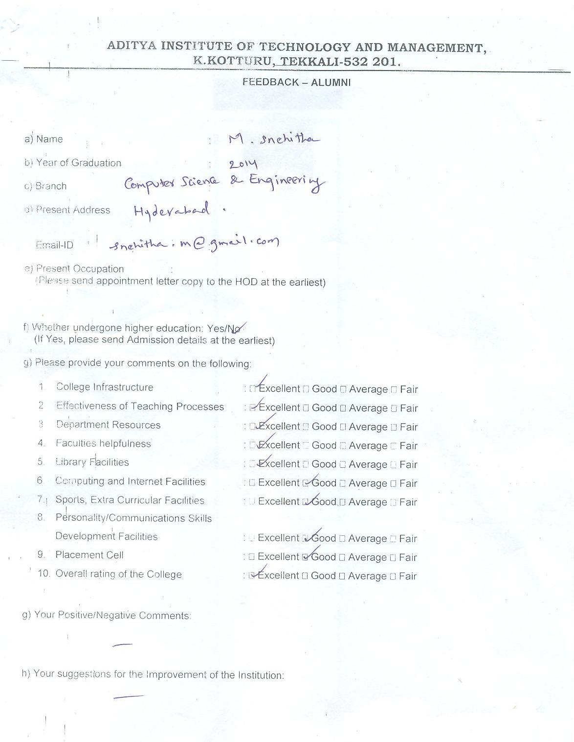

Parents Feedback
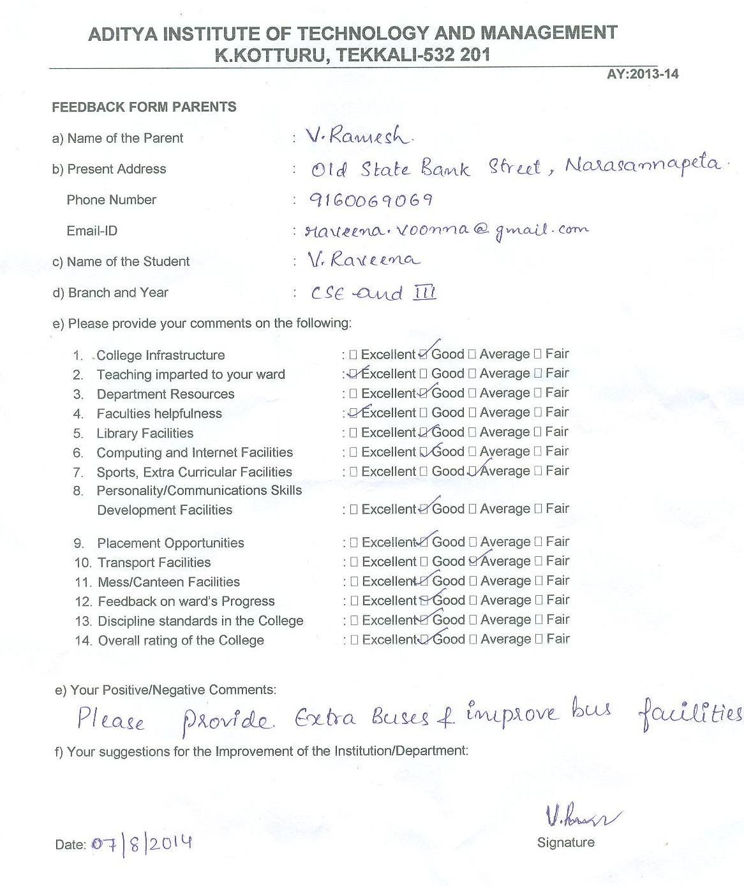

Annexure-II

ACADEMIC CALENDAR
2013-2014
JUNE 2013
DAY | DATE | EVENT
SAT | 1
SUN | 2 | HOLIDAY
MON | 3
TUE | 4
WED | 5
THU | 6 | III & IV Year 1st Semester Class Work Start
FRI | 7
SAT | 8 | HOLIDAY
SUN | 9 | HOLIDAY
MON | 10
TUE | 11
WED | 12
THU | 13
FRI | 14
SAT | 15
SUN | 16 | HOLIDAY
MON | 17
TUE | 18
WED | 19
THU | 20
FRI | 21
SAT | 22
SUN | 23 | HOLIDAY
MON | 24
TUE | 25
WED | 26
THU | 27
FRI | 28
SAT | 29
SUN | 30 | HOLIDAY
July 2013
DAY | DATE
MON | 1
TUE | 2
WED | 3
THU | 4
FRI | 5
SAT | 6
SUN | 7 | HOLIDAY
MON | 8
TUE | 9
WED | 10
THU | 11
FRI | 12
SAT | 13 | HOLIDAY
SUN | 14 | HOLIDAY
MON | 15
TUE | 16
WED | 17
THU | 18
FRI | 19
SAT | 20
SUN | 21 | HOLIDAY
MON | 22
TUE | 23
WED | 24
THU | 25
FRI | 26
SAT | 27
SUN | 28 | HOLIDAY
MON | 29
TUE | 30
TUE | 31
AUGUST 2013
DAY | DATE | EVENT
THU | 1
FRI | 2
SAT | 3
SUN | 4 | HOLIDAY
MON | 5
TUE | 6 | III & IV Year 1st Semester 1st QUIZ & MID Examinations
WED | 7 | III & IV Year 1st Semester 1st QUIZ & MID Examinations
THU | 8 | III & IV Year 1st Semester 1st QUIZ & MID Examinations
FRI | 9 | HOLIDAY (Id-Ul-Fitr)
SAT | 10 | HOLIDAY
SUN | 11 | HOLIDAY
MON | 12 | III & IV Year 1st Semester 1st QUIZ & MID Examinations &  II Year 1st Semester Class Work Start
TUE | 13 | III & IV Year 1st Semester 1st QUIZ & MID Examinations
WED | 14
THU | 15 | HOLIDAY (Independence Day)
FRI | 16
SAT | 17
SUN | 18 | HOLIDAY
MON | 19 | Makeup Classes for III & IV Year 1st Semester Students
TUE | 20 | Makeup Classes for III & IV Year 1st Semester Students
WED | 21 | Makeup Classes for III & IV Year 1st Semester Students
THU | 22 | Makeup Classes for III & IV Year 1st Semester Students
FRI | 23 | Makeup Classes for III & IV Year 1st Semester Students
SAT | 24 | Makeup Classes for III & IV Year 1st Semester Students
SUN | 25 | HOLIDAY
MON | 26
TUE | 27
WED | 28 | HOLIDAY (Krishna Janmastami)
THU | 29
FRI | 30
SAT | 31
SEPTMBER 2013
DAY | DATE | EVENT
SUN | 1 | HOLIDAY
MON | 2
TUE | 3
WED | 4
THU | 5
FRI | 6
SAT | 7
SUN | 8 | HOLIDAY
MON | 9 | HOLIDAY (Ganesh Chaturthi)
TUE | 10
WED | 11
THU | 12
FRI | 13
SAT | 14 | HOLIDAY
SUN | 15 | HOLIDAY
MON | 16 | Remedial Classes for III & IV Year Students
TUE | 17 | Remedial Classes for III & IV Year Students
WED | 18 | Remedial Classes for III & IV Year Students
THU | 19 | Remedial Classes for III & IV Year Students
FRI | 20 | Remedial Classes for III & IV Year Students
SAT | 21 | Remedial Classes for III & IV Year Students
SUN | 22 | HOLIDAY
MON | 23
TUE | 24
WED | 25
THU | 26
FRI | 27
SAT | 28
SUN | 29 | HOLIDAY
MON | 30 | I Year (Autonomous) 1st Semester Class Work Start
OCTOBER 2013
DAY | DATE | EVENT
TUE | 1
WED | 2 | HOLIDAY (Mahatma Gandhi Jayanthi)
THU | 3
FRI | 4
SAT | 5
SUN | 6 | HOLIDAY
MON | 7 | II Year 1st Semester 1st QUIZ & MID Examinations &  III & IV Year 1st Semester 2nd QUIZ & MID Examinations
TUE | 8 | II Year 1st Semester 1st QUIZ & MID Examinations &  III & IV Year 1st Semester 2nd QUIZ & MID Examinations
WED | 9 | II Year 1st Semester 1st QUIZ & MID Examinations &  III & IV Year 1st Semester 2nd QUIZ & MID Examinations
THU | 10 | II Year 1st Semester 1st QUIZ & MID Examinations &  III & IV Year 1st Semester 2nd QUIZ & MID Examinations
FRI | 11 | II Year 1st Semester 1st QUIZ & MID Examinations &  III & IV Year 1st Semester 2nd QUIZ & MID Examinations
SAT | 12 | HOLIDAY (Vijaya Dashami)
SUN | 13 | HOLIDAY (Vijaya Dashami)
MON | 14 | II Year 1st Semester 1st QUIZ & MID Examinations &  III & IV Year 1st Semester 2nd QUIZ & MID Examinations
TUE | 15 | III & IV Year 1st Semester PRACTICAL END Examinations &  Preparation Holidays
WED | 16 | HOLIDAY (Bakri Id)
THU | 17 | III & IV Year 1st Semester PRACTICAL END Examinations &  Preparation Holidays
FRI | 18 | III & IV Year 1st Semester PRACTICAL END Examinations &  Preparation Holidays
SAT | 19 | III & IV Year 1st Semester PRACTICAL END Examinations &  Preparation Holidays
SUN | 20 | HOLIDAY
MON | 21 | Makeup Classes for II Year 1st Semester Students &  III & IV Year 1st Semester PRACTICAL END Examinations &  Preparation Holidays
TUE | 22 | Makeup Classes for II Year 1st Semester Students &  III & IV Year 1st Semester PRACTICAL END Examinations &  Preparation Holidays
WED | 23 | Makeup Classes for II Year 1st Semester Students &  III & IV Year 1st Semester PRACTICAL END Examinations &  Preparation Holidays
THU | 24 | Makeup Classes for II Year 1st Semester Students &  III & IV Year 1st Semester PRACTICAL END Examinations &  Preparation Holidays &  Three Day National Seminar on "Intelligent System and Machine Learing" by MCA Dept.
FRI | 25 | Makeup Classes for II Year 1st Semester Students &  III & IV Year 1st Semester PRACTICAL END Examinations &  Preparation Holidays
SAT | 26 | Makeup Classes for II Year 1st Semester Students &  III & IV Year 1st Semester PRACTICAL END Examinations &  Preparation Holidays
SUN | 27 | HOLIDAY
MON | 28 | III & IV Year 1st Semester END Examinations
TUE | 29 | III & IV Year 1st Semester END Examinations
WED | 30 | III & IV Year 1st Semester END Examinations
THU | 31 | III & IV Year 1st Semester END Examinations
NOVEMBER 2013
DAY | DATE | EVENT
FRI | 1 | III & IV Year 1st Semester END Examinations
SAT | 2 | III & IV Year 1st Semester END Examinations
SUN | 3 | HOLIDAY (Diwali)
MON | 4 | III & IV Year 1st Semester END Examinations
TUE | 5 | III & IV Year 1st Semester END Examinations
WED | 6 | III & IV Year 1st Semester END Examinations
THU | 7 | III & IV Year 1st Semester END Examinations
FRI | 8 | III & IV Year 1st Semester END Examinations
SAT | 9 | III & IV Year 1st Semester END Examinations
SUN | 10 | HOLIDAY
MON | 11 | III & IV Year 2nd Semester Class Work Start &  I Year (Autonomous) 1st Semester 1st MID Examinations
TUE | 12 | I Year (Autonomous) 1st Semester 1st MID Examinations
WED | 13 | I Year (Autonomous) 1st Semester 1st MID Examinations
THU | 14
FRI | 15 | HOLIDAY (Muharram)
SAT | 16
SUN | 17 | HOLIDAY (Guru Nanak Jayanthi)
MON | 18 | Remedial Classes for II Year Students
TUE | 19 | Remedial Classes for II Year Students
WED | 20 | Remedial Classes for II Year Students
THU | 21 | Remedial Classes for II Year Students
FRI | 22 | Remedial Classes for II Year Students &  Three Day Faculty Development Program on "Entrepreneurship Awareness Programme" by MBA Dept.
SAT | 23 | Remedial Classes for II Year Students
SUN | 24 | HOLIDAY
MON | 25 | Makeup Classes for I Year 1st Semester Students
TUE | 26 | Makeup Classes for I Year 1st Semester Students
WED | 27 | Makeup Classes for I Year 1st Semester Students
THU | 28 | Makeup Classes for I Year 1st Semester Students
FRI | 29 | Makeup Classes for I Year 1st Semester Students
SAT | 30 | Makeup Classes for I Year 1st Semester Students
DECEMBER 2013
DAY | DATE | EVENT
SUN | 1 | HOLIDAY
MON | 2 | Remedial Classes for I Year Students
TUE | 3 | Remedial Classes for I Year Students
WED | 4 | Remedial Classes for I Year Students
THU | 5 | Remedial Classes for I Year Students
FRI | 6 | Remedial Classes for I Year Students
SAT | 7 | Remedial Classes for I Year Students
SUN | 8 | HOLIDAY
MON | 9 | II Year 1st Semester 2nd QUIZ & MID Examinations
TUE | 10 | II Year 1st Semester 2nd QUIZ & MID Examinations
WED | 11 | II Year 1st Semester 2nd QUIZ & MID Examinations
THU | 12 | II Year 1st Semester 2nd QUIZ & MID Examinations
FRI | 13 | II Year 1st Semester 2nd QUIZ & MID Examinations
SAT | 14 | II Year 1st Semester 2nd QUIZ & MID Examinations
SUN | 15 | HOLIDAY
MON | 16 | II Year 2nd Semester 2nd QUIZ & MID Examinations
TUE | 17 | II Year 1st Semester PRACTICAL END Examinations and Preparation Holidays
WED | 18 | II Year 1st Semester PRACTICAL END Examinations and Preparation Holidays
THU | 19 | I Year (Autonomous) 1st Semester 2nd MID Examinations &  II Year 1st Semester PRACTICAL END Examinations and Preparation Holidays
FRI | 20 | I Year (Autonomous) 1st Semester 2nd MID Examinations &  II Year 1st Semester PRACTICAL END Examinations and Preparation Holidays
SAT | 21 | I Year (Autonomous) 1st Semester 2nd MID Examinations &  II Year 1st Semester PRACTICAL END Examinations and Preparation Holidays
SUN | 22 | HOLIDAY
MON | 23 | II Year 1st Semester PRACTICAL END Examinations and Preparation Holidays
TUE | 24 | II Year 1st Semester PRACTICAL END Examinations and Preparation Holidays
WED | 25 | HOLIDAY (Christmas)
THU | 26 | II Year 1st Semester PRACTICAL END Examinations and Preparation Holidays & A Short Term Training Programme on "Soft Computing Applications to Power Systems" by EEE Dept.
FRI | 27 | II Year 1st Semester PRACTICAL END Examinations and Preparation Holidays
SAT | 28 | II Year 1st Semester PRACTICAL END Examinations and Preparation Holidays
SUN | 29 | HOLIDAY
MON | 30 | Makeup Classes for I year 2nd Semester Students &  II Year 1st Semester END Examinations
TUE | 31 | Makeup Classes for I year 2nd Semester Students &  II Year 1st Semester END Examinations
January 2014
DAY | DATE | EVENT
WED | 1 | HOLIDAY (New Year's Day)
THU | 2 | Makeup Classes for I Year 2nd Semester Students &  II Year 1st Semester END Examinations
FRI | 3 | Makeup Classes for I Year 2nd Semester Students &  II Year 1st Semester END Examinations
SAT | 4 | Makeup Classes for I Year 2nd Semester Students &  II Year 1st Semester END Examinations
SUN | 5 | HOLIDAY
MON | 6 | II Year 1st Semester END Examinations &  III & IV Year 2nd Semester 1st QUIZ & MID Examinations
TUE | 7 | II Year 1st Semester END Examinations &  III & IV Year 2nd Semester 1st QUIZ & MID Examinations
WED | 8 | II Year 1st Semester END Examinations &  III & IV Year 2nd Semester 1st QUIZ & MID Examinations &  Three Day Workshop on "Frontiers in Machine Learning Algorithms"  by CSE Dept.
THU | 9 | II Year 1st Semester END Examinations &  III & IV Year 2nd Semester 1st QUIZ & MID Examinations &  Industrial Tour for 3rd Civil
FRI | 10 | II Year 1st Semester END Examinations &  III & IV Year 2nd Semester 1st QUIZ & MID Examinations
SAT | 11 | II Year 1st Semester END Examinations &  III & IV Year 2nd Semester 1st QUIZ & MID Examinations
SUN | 12 | HOLIDAY
MON | 13 | HOLIDAY (Bhogi)
TUE | 14 | HOLIDAY (Pongal)
WED | 15
THU | 16
FRI | 17
SAT | 18
SUN | 19 | HOLIDAY
MON | 20 | II Year 2nd Semester Class Work Start &  Makeup Classes for III & IV Year 2nd Semester Students
TUE | 21 | Makeup Classes for III & IV Year 2nd Semester Students
WED | 22 | Makeup Classes for III & IV Year 2nd Semester Students
THU | 23 | Makeup Classes for III & IV Year 2nd Semester Students
FRI | 24 | Makeup Classes for III & IV Year 2nd Semester Students
SAT | 25 | Makeup Classes for III & IV Year 2nd Semester Students
SUN | 26 | HOLIDAY (Republic Day)
MON | 27
TUE | 28
WED | 29
THU | 30 | I Year (Autonomous) 1st Semester 3nd MID Examinations &  Industrial Tour for 2nd ECE-B
FRI | 31 | I Year (Autonomous) 1st Semester 3nd MID Examinations
February 2014
DAY | DATE | EVENT
SAT | 1 | I Year (Autonomous) 1st Semester 3nd MID Examinations &  Industrial Tour for 3rd CSE-B, 3rd IT & 2nd ECE-B
SUN | 2
MON | 3 | I Year (Autonomous) 1st Semester Preparation Holidays
TUE | 4 | I Year (Autonomous) 1st Semester Preparation Holidays
WED | 5 | I Year (Autonomous) 1st Semester Preparation Holidays &  Industrial Tour for 3rd CSE-A, 2nd EIE & 2nd ECE-A
THU | 6 | I Year (Autonomous) 1st Semester Preparation Holidays
FRI | 7 | I Year (Autonomous) 1st Semester Preparation Holidays &  Industrial Tour for 2nd EIE & ECE-A
SAT | 8 | HOLIDAY & 2nd IT Industrial Tour
SUN | 9 | HOLIDAY
MON | 10 | I Year (Autonomous) 1st Semester END Examinations
TUE | 11 | I Year (Autonomous) 1st Semester END Examinations
WED | 12 | I Year (Autonomous) 1st Semester END Examinations
THU | 13 | I Year (Autonomous) 1st Semester END Examinations
FRI | 14 | I Year (Autonomous) 1st Semester END Examinations
SAT | 15 | I Year (Autonomous) 1st Semester END Examinations
SUN | 16 | HOLIDAY
MON | 17 | I Year (Autonomous) 1st Semester END Examinations
TUE | 18 | I Year (Autonomous) 1st Semester END Examinations
WED | 19 | I Year (Autonomous) 1st Semester END Examinations
THU | 20 | I Year (Autonomous) 1st Semester END Examinations
FRI | 21 | I Year (Autonomous) 1st Semester END Examinations &  Industrial Tour for 3rd ECE-B
SAT | 22 | I Year (Autonomous) 1st Semester END Examinations
SUN | 23 | HOLIDAY
MON | 24 | I Year (Autonomous) 1st Semester PRACTICAL END Examinations
TUE | 25 | I Year (Autonomous) 1st Semester PRACTICAL END Examinations
WED | 26 | I Year (Autonomous) 1st Semester PRACTICAL END Examinations
THU | 27 | HOLIDAY (Maha Shivratri )
FRI | 28 | I Year (Autonomous) 1st Semester PRACTICAL END Examinations
March 2014
DAY | DATE | EVENT
SAT | 1 | I Year (Autonomous) 1st Semester PRACTICAL END Examinations
SUN | 2 | HOLIDAY
MON | 3 | I Year (Autonomous) 2nd Semester Class Work Start
TUE | 4
WED | 5
THU | 6
FRI | 7
SAT | 8 | HOLIDAY
SUN | 9 | HOLIDAY
MON | 10 | Remedial Classes for III & IV Year Students
TUE | 11 | Remedial Classes for III & IV Year Students
WED | 12 | Remedial Classes for III & IV Year Students
THU | 13 | Remedial Classes for III & IV Year Students
FRI | 14 | Remedial Classes for III & IV Year Students
SAT | 15 | Remedial Classes for III & IV Year Students
SUN | 16 | HOLIDAY
MON | 17 | HOLIDAY (Holi)
TUE | 18 | II Year 2nd Semester 1st QUIZ & MID Examinations &  III & IV Year 2nd Semester 2nd QUIZ & MID Examinations
WED | 19 | II Year 2nd Semester 1st QUIZ & MID Examinations &  III & IV Year 2nd Semester 2nd QUIZ & MID Examinations
THU | 20 | II Year 2nd Semester 1st QUIZ & MID Examinations &  III & IV Year 2nd Semester 2nd QUIZ & MID Examinations
FRI | 21 | II Year 2nd Semester 1st QUIZ & MID Examinations &  III & IV Year 2nd Semester 2nd QUIZ & MID Examinations
SAT | 22 | II Year 2nd Semester 1st QUIZ & MID Examinations &  III & IV Year 2nd Semester 2nd QUIZ & MID Examinations
SUN | 23 | HOLIDAY
MON | 24 | II Year 2nd Semester 1st QUIZ & MID Examinations &  III & IV Year 2nd Semester 2nd QUIZ & MID Examinations
TUE | 25 | III & IV Year 2nd Semester PRACTICAL END Examinations &  Preparation Holidays
WED | 26 | III & IV Year 2nd Semester PRACTICAL END Examinations &  Preparation Holidays
THU | 27 | III & IV Year 2nd Semester PRACTICAL END Examinations &  Preparation Holidays
FRI | 28 | III & IV Year 2nd Semester PRACTICAL END Examinations &  Preparation Holidays
SAT | 29 | III & IV Year 2nd Semester PRACTICAL END Examinations &  Preparation Holidays
SUN | 30 | HOLIDAY
MON | 31
APRIL 2014
DAY | DATE | EVENT
TUE | 1 | Makeup Classes for II Year 2nd Semester Students &  III & IV Year 2nd Semester PRACTICAL END Examinations & Preparation Holidays
WED | 2 | Makeup Classes for II Year 2nd Semester Students &  III & IV Year 2nd Semester PRACTICAL END Examinations & Preparation Holidays
THU | 3 | Makeup Classes for II Year 2nd Semester Students &  III & IV Year 2nd Semester PRACTICAL END Examinations & Preparation Holidays
FRI | 4 | Makeup Classes for II Year 2nd Semester Students &  III & IV Year 2nd Semester PRACTICAL END Examinations & Preparation Holidays
SAT | 5 | Makeup Classes for II Year 2nd Semester Students &  III & IV Year 2nd Semester PRACTICAL END Examinations & Preparation Holidays
SUN | 6 | HOLIDAY
MON | 7 | III & IV Year 2nd Semester END Examinations
TUE | 8 | III & IV Year 2nd Semester END Examinations
WED | 9 | III & IV Year 2nd Semester END Examinations
THU | 10 | III & IV Year 2nd Semester END Examinations
FRI | 11 | III & IV Year 2nd Semester END Examinations
SAT | 12 | HOLIDAY
SUN | 13 | HOLIDAY (Mahavir Jayanthi)
MON | 14 | III & IV Year 2nd Semester END Examinations
TUE | 15 | I Year (Autonomous) 2nd Semester 1st MID Examinations &  III & IV Year 2nd Semester END Examinations
WED | 16 | I Year (Autonomous) 2nd Semester 1st MID Examinations &  III & IV Year 2nd Semester END Examinations
THU | 17 | I Year (Autonomous) 2nd Semester 1st MID Examinations &  III & IV Year 2nd Semester END Examinations &  Industrial Tour for 2nd CSE-B
FRI | 18 | HOLIDAY (Good Friday) & 2nd CSE-A & C Industrial Tour
SAT | 19 | III & IV Year 2nd Semester END Examinations
SUN | 20 | HOLIDAY
MON | 21 | Makeup Classes for I Year 2nd Semester Students &  Summer Vacations for 3rd B.Tech
TUE | 22 | Makeup Classes for I Year 2nd Semester Students &  Summer Vacations for 3rd B.Tech & 4 IT Industrial Tour
WED | 23 | Makeup Classes for I Year 2nd Semester Students &  Summer Vacations for 3rd B.Tech
THU | 24 | Makeup Classes for I Year 2nd Semester Students &  Summer Vacations for 3rd B.Tech
FRI | 25 | Makeup Classes for I Year 2nd Semester Students &  Summer Vacations for 3rd B.Tech
SAT | 26 | Makeup Classes for I Year 2nd Semester Students &  Summer Vacations for 3rd B.Tech
SUN | 27 | HOLIDAY
MON | 28 | Summer Vacations for 3rd B.Tech
TUE | 29 | Summer Vacations for 3rd B.Tech
WED | 30 | Summer Vacations for 3rd B.Tech
MAY 2014
DAY | DATE | EVENT
THU | 1 | Summer Vacations for 3rd B.Tech
FRI | 2 | Summer Vacations for 3rd B.Tech
SAT | 3 | Summer Vacations for 3rd B.Tech
SUN | 4 | HOLIDAY
MON | 5 | Summer Vacations for Ist & 3rd B.Tech &  Remedial Classes for II Year Students
TUE | 6 | Summer Vacations for Ist & 3rd B.Tech &  Remedial Classes for II Year Students
WED | 7 | Summer Vacations for Ist & 3rd B.Tech &  Remedial Classes for II Year Students
THU | 8 | Summer Vacations for Ist & 3rd B.Tech &  Remedial Classes for II Year Students
FRI | 9 | Summer Vacations for Ist & 3rd B.Tech &  Remedial Classes for II Year Students
SAT | 10 | HOLIDAY
SUN | 11 | HOLIDAY
MON | 12
TUE | 13 | Summer Vacations for Ist & 3rd B.Tech
WED | 14 | Summer Vacations for Ist & 3rd B.Tech
THU | 15 | Summer Vacations for Ist & 3rd B.Tech
FRI | 16 | Summer Vacations for Ist & 3rd B.Tech
SAT | 17 | Summer Vacations for 3rd B.Tech
SUN | 18 | HOLIDAY
MON | 19 | II Year 2nd Semester 2nd QUIZ & MID Examinations &  Summer Vacations for 3rd B.Tech
TUE | 20 | II Year 2nd Semester 2nd QUIZ & MID Examinations &  Summer Vacations for 3rd B.Tech
WED | 21 | II Year 2nd Semester 2nd QUIZ & MID Examinations &  Summer Vacations for 3rd B.Tech
THU | 22 | II Year 2nd Semester 2nd QUIZ & MID Examinations &  Summer Vacations for 3rd B.Tech
FRI | 23 | II Year 2nd Semester 2nd QUIZ & MID Examinations &  Summer Vacations for 3rd B.Tech
SAT | 24 | II Year 2nd Semester 2nd QUIZ & MID Examinations &  Summer Vacations for 3rd B.Tech
SUN | 25 | HOLIDAY
MON | 26 | II Year 2nd Semester PRACTICAL END Examinations and Preparation Holidays & Summer Vacations for 3rd B.Tech
TUE | 27 | II Year 2nd Semester PRACTICAL END Examinations and Preparation Holidays & Summer Vacations for 3rd B.Tech
WED | 28 | II Year 2nd Semester PRACTICAL END Examinations and Preparation Holidays & Summer Vacations for 3rd B.Tech
THU | 29 | II Year 2nd Semester PRACTICAL END Examinations &  Preparation Holidays
FRI | 30 | II Year 2nd Semester PRACTICAL END Examinations &  Preparation Holidays
SAT | 31 | II Year 2nd Semester PRACTICAL END Examinations &  Preparation Holidays
JUNE 2014
DAY | DATE | EVENT
SUN | 1 | HOLIDAY
MON | 2 | II Year 2nd Semester PRACTICAL END Examinations &  Preparation Holidays
TUE | 3 | II Year 2nd Semester PRACTICAL END Examinations &  Preparation Holidays
WED | 4 | II Year 2nd Semester PRACTICAL END Examinations &  Preparation Holidays
THU | 5 | II Year 2nd Semester PRACTICAL END Examinations &  Preparation Holidays
FRI | 6 | II Year 2nd Semester PRACTICAL END Examinations &  Preparation Holidays
SAT | 7 | II Year 2nd Semester PRACTICAL END Examinations &  Preparation Holidays
SUN | 8 | HOLIDAY
MON | 9 | II Year 2nd Semester END Examinations
TUE | 10 | II Year 2nd Semester END Examinations
WED | 11 | II Year 2nd Semester END Examinations
THU | 12 | II Year 2nd Semester END Examinations
FRI | 13 | II Year 2nd Semester END Examinations
SAT | 14 | HOLIDAY
SUN | 15 | HOLIDAY
MON | 16 | II Year 2nd Semester END Examinations
TUE | 17 | II Year 2nd Semester END Examinations
WED | 18 | II Year 2nd Semester END Examinations
THU | 19 | II Year 2nd Semester END Examinations
FRI | 20 | II Year 2nd Semester END Examinations
SAT | 21 | II Year 2nd Semester END Examinations
SUN | 22 | HOLIDAY
MON | 23 | I Year (Autonomous) 2nd Semester 2nd MID Examinations &  Summer Vacations for 2nd B.Tech
TUE | 24 | I Year (Autonomous) 2nd Semester 2nd MID Examinations &  Summer Vacations for 2nd B.Tech
WED | 25 | I Year (Autonomous) 2nd Semester 2nd MID Examinations &  Summer Vacations for 2nd B.Tech
THU | 26
FRI | 27
SAT | 28
SUN | 29 | HOLIDAY
MON | 30
July 2014
DAY | DATE | EVENTS
TUE | 1
WED | 2
THU | 3
FRI | 4
SAT | 5
SUN | 6 | HOLIDAY
MON | 7
TUE | 8
WED | 9
THU | 10
FRI | 11
SAT | 12 | HOLIDAY
SUN | 13 | HOLIDAY
MON | 14 | Remedial Classes for I Year Students
TUE | 15 | Remedial Classes for I Year Students
WED | 16 | Remedial Classes for I Year Students
THU | 17 | Remedial Classes for I Year Students
FRI | 18 | Remedial Classes for I Year Students
SAT | 19 | Remedial Classes for I Year Students
SUN | 20 | HOLIDAY
MON | 21
TUE | 22
WED | 23
THU | 24
FRI | 25
SAT | 26
SUN | 27 | HOLIDAY
MON | 28
TUE | 29 | HOLIDAY ( Id-Ul-Fitr)
WED | 30
THU | 31 | I Year (Autonomous) 2nd Semester 3rd MID Examinations
AUGUST 2014
DAY | DATE | EVENT
FRI | 1 | I Year (Autonomous) 2nd Semester 3rd MID Examinations
SAT | 2 | I Year (Autonomous) 2nd Semester 3rd MID Examinations
SUN | 3 | HOLIDAY
MON | 4 | I Year (Autonomous) 2nd Semester Preparation Holidays
TUE | 5 | I Year (Autonomous) 2nd Semester Preparation Holidays
WED | 6 | I Year (Autonomous) 2nd Semester Preparation Holidays
THU | 7 | I Year (Autonomous) 2nd Semester Preparation Holidays
FRI | 8 | I Year (Autonomous) 2nd Semester Preparation Holidays
SAT | 9 | HOLIDAY
SUN | 10 | HOLIDAY
MON | 11 | I Year (Autonomous) 2nd Semester END Examinations
TUE | 12 | I Year (Autonomous) 2nd Semester END Examinations
WED | 13 | I Year (Autonomous) 2nd Semester END Examinations
THU | 14 | I Year (Autonomous) 2nd Semester END Examinations
FRI | 15 | HOLIDAY (Independence Day)
SAT | 16 | I Year (Autonomous) 2nd Semester END Examinations
SUN | 17 | HOLIDAY
MON | 18 | HOLIDAY (Krishna Janmastami)
TUE | 19 | I Year (Autonomous) 2nd Semester END Examinations
WED | 20 | I Year (Autonomous) 2nd Semester END Examinations
THU | 21 | I Year (Autonomous) 2nd Semester END Examinations
FRI | 22 | I Year (Autonomous) 2nd Semester END Examinations
SAT | 23 | I Year (Autonomous) 2nd Semester END Examinations
SUN | 24 | HOLIDAY
MON | 25 | I Year (Autonomous) 2nd Semester PRACTICAL END Examinations
TUE | 26 | I Year (Autonomous) 2nd Semester PRACTICAL END Examinations
WED | 27 | I Year (Autonomous) 2nd Semester PRACTICAL END Examinations
THU | 28 | I Year (Autonomous) 2nd Semester PRACTICAL END Examinations
FRI | 29 | HOLIDAY (Ganesh Chaturthi)
SAT | 30 | I Year (Autonomous) 2nd Semester PRACTICAL END Examinations
SUN | 31 | HOLIDAY

Annexure-III

1. Title of the Practice - Placement Cell and Career Counselling:

a) Goal:
- To make students competent and make them aware about the recent trends in industries
relating to employment opportunities.
- To identify and provide exposure to exhibit their skills and talent.
- To guide the students to overcome problems that they are facing.
- To counsel the students suffering from social and economic problems.
- To prepare the students for work environment.
- To make the students competent in communication skills and make them ready for the
future challenges.
- To make students realize social responsibilities.

We presume that our responsibility is not only to educate students but also to help them in their future career development process. Considering this, we have established the above cell. The basic purpose is to orient students about the skills required by the companies. This cell has been established to provide gateway to the students in the industry. Majority of the students are not aware about their talent for which we in association with various institutes organize tests and
accordingly gauge their intent and potential for future career and placement.

b) The Context:

Through Career Counselling Cell, we organize various lectures and seminars for Personality Development of the students. Lectures include topics like Communication Skill, Current industrial scenario and expectation of industries as well as how to face interviews etc. We invite many companies for providing campus base placement opportunities to the students to ease the process of recruitment and placement. Students face various problems in their learning and academic growth. The social and economical problems disturb their academic growth. Lack of awareness of their own abilities and talent results in poor academic performance. To overcome this problem, it is essential to provide counselling to the students and motivate them to do better in their studies. Counselling helps students to develop discipline in their personal life and also in the college. Enrolled students of the college are from socially and educationally backward families and also from rural area. They are not exposed to media like Internet, English
Newspapers. Computer etc. The Students of the first generation need educational and career
guidance through orientation and personal counselling. In today’s competitive world, it has been
a very challenging task to place the students in the companies. Students require communication
skills, confidence and subject knowledge. Industry expectations are on a higher side.

c) The Practice:

The personal Counselling Cell is constituted for the benefit of all the students of the college. All the faculty members are involved in the process of counselling. The college placement cell organizes guest lectures on Career Guidance and Employment opportunities by inviting experts from industries and companies. The placement cell conducted various informative sessions, talks and programs to help students to understand the nature of the jobs. The career guidance and placement cell conduct some special courses in basic mathematics, communication skills, mock interview etc.. The college library has a number of books, journals, periodicals to help students in preparing to take up competitive examinations. The main endeavour of the placement cell is to get students placed in reputed multinational companies, government, NGO's and other private sectors. The cell assures support to the visiting companies at every stage of the placement process by making infrastructure and students available to them. The cell will act as an interface between the industry and the students. The cell liaisons with corporate organizations to provide suitable jobs for the candidates completing their studies from the college. The cell also conducts seminars and workshops to enable the students of college to become successful professionals. The cell is well connected with the corporate officers and companies.. The companies will conduct a separate entrance test in college premises and shortlist the candidates after the interviews.

Evidence of Success: A good number of students are selected in campus interview.

2. Title of the Practice - Remedial Classes:

a) Goal:
The aim of this practice followed by the institution is to bring improvement in the slow learners who need individual attention.
b) Context:
The challenging issue that have had been addressed in designing and implementing the practice of remedial classes is reduce the number of students attending tuitions outside the college. When the students are not able to follow in the class these Remedial Classes will help then to learn and follow the subject. Some students specially slow learners need additional and individual attention. These remedial classes have benefited them a lot.
c) The Practice:
The practice and implementation of the Remedial Classes is made effective from the beginning of each semester in all the streams. The list of slow learners is made from each class in each subject and two days in a week is assigned for each subject and students are supposed to attend these remedial classes. Separate attendance will be taken for each remedial class students are given exams after each chapter to know about their performance after attending remedial class.
d) Evidence of Success:
The review results of Remedial Classes process that it has been very effective to the students. Most of the students attending remedial classes have cleared their pending subjects.

