Annual Quality Assurance Report
(AQAR) – 2014-15

Submitted To

National Assessment and Accreditation Council (NAAC)

Submitted By

Aditya Institute of Technology and Management
(An Autonomous Institution)
Approved by AICTE, Permanently affiliated to JNTU, Kakinada
Accredited by NBA & NAAC, Recognised by UGC under 2(f), 12(b)
K.Kotturu (Vill), Tekkali, Srikakulam-Dist., A.P-532201
Website: www.adityatekkali.edu.in
Email: aditya_tekkali@yahoo.com

The Annual Quality Assurance Report (AQAR) of the IQAC

All NAAC accredited institutions will submit an annual self-reviewed progress report to NAAC, through its IQAC. The report is to detail the tangible results achieved in key areas, specifically identified by the institutional IQAC at the beginning of the academic year. The AQAR will detail the results of the perspective plan worked out by the IQAC.

Part – A

Aditya Institute of Technology and Management
1. Details of the Institution
1.1 Name of the Institution

K.Kotturu
1.2 Address Line 1

Tekkali
Address Line 2

Srikakulam
City/Town

Andhra Pradesh
State

532201
Pin Code
aditya_tekkali@yahoo.com

Institution e-mail address
9246657904, 9440195534

Contact Nos.
Prof. V.V. Nageswara Rao

Name of the Head of the Institution:
(+91) 8945-245666, 245266

Tel. No. with STD Code:

9246657904

Mobile:
Dr. Ch. Ramesh

Name of the IQAC Co-ordinator:
9247858288

Mobile:
iqac@adityatekkali.edu.in
iqacadityatekkali@gmail.com

IQAC e-mail address:
AITAM11471

1.3 NAAC Track ID

NAAC/A&AOC/EC-56/57/2011, Dated 16-09-2011
1.4 NAAC Executive Committee No. & Date:
(For Example EC/32/A&A/143 dated 3-5-2004.
This EC no. is available in the right corner-bottom
of your institution’s Accreditation Certificate)

www.adityatekkali.edu.in

1.5 Website address:
http://www.adityatekkali.edu.in/AQAR2014-15.doc

Web-link of the AQAR:

1.6 Accreditation Details
Sl. No. | Cycle | Grade | CGPA | Year of Accreditation | Validity Period
1 | 1st Cycle | B | 2.44 | 2011 | 16-09-2011 to 15-09-2016 (5 years)
2 | 2nd Cycle | - | - | - | -
3 | 3rd Cycle | - | - | - | -
4 | 4th Cycle | - | - | - | -

12/12/2001
1.7 Date of Establishment of IQAC: DD/MM/YYYY

2014-15

1.8 AQAR for the year (for example 2010-11)

1.9 Details of the previous year’s AQAR submitted to NAAC after the latest Assessment and Accreditation by NAAC
- AQAR 2011-12, 10-10-2014 (DD/MM/YYYY)
- AQAR 2012-13, 10-10-2014 (DD/MM/YYYY)
- AQAR 2013-14, 20-03-2015 (DD/MM/YYYY)
- AQAR 2014-15, 10-09-2015 (DD/MM/YYYY)
1.10 Institutional Status

University State Central Deemed Private
√

Affiliated College Yes No

Constituent College Yes No
√

√

Autonomous college of UGC Yes No

√
Regulatory Agency approved Institution Yes No
(Eg. AICTE, BCI, MCI, PCI, NCI)
√

Type of Institution Co-education Men Women
√

Urban Rural Tribal

√
√

Financial Status Grant-in-aid UGC 2(f) UGC 12B
√

Grant-in-aid + Self Financing Totally Self-Financing

1.11 Type of Faculty/Programme

Arts Science Commerce Law PEI (Phys Edu)

√
TEI (Edu) Engineering Health Science Management

-

Others (Specify)

JNTUK, Kakinada

1.12 Name of the Affiliating University
(For the Colleges)

1.13 Special status conferred by Central/ State Government-- UGC/CSIR/DST/DBT/ICMR etc
University
Autonomy by State/Central Govt. / University
-
University with Potential for Excellence UGC-CPE
-
-
-
DST Star Scheme UGC-CE
-
-
UGC-Special Assistance Programme DST-FIST
-
-
UGC-Innovative PG programmes Any other (Specify)
-
UGC-COP Programmes
2. IQAC Composition and Activities
08
2.1 No. of Teachers
02
2.2 No. of Administrative/Technical staff
02
2.3 No. of students
2.4 No. of Management representatives
02
02
2.5 No. of Alumni
2.6 No. of any other stakeholder and
02
community representatives
2.7 No. of Employers/ Industrialists
01

2.8 No. of other External Experts
01
2.9 Total No. of members 20
20
2.10 No. of IQAC meetings held
03
02
05
2.11 No. of meetings with various stakeholders No. Faculty
01
01
01
Non-Teaching Staff Students Alumni Others
√
2.12 Has IQAC received any funding from UGC during the year? Yes No

-
If yes, mention the amount
2.13 Seminars and Conferences (only quality related)
(i) No. of Seminars/Conferences/ Workshops/Symposia organized by the IQAC
5

53
Total Nos. International National State Institution Level
Outcome Based Education

(ii) Themes

2.14 Significant Activities and contributions made by IQAC
- Academic auditing
- Orientation Programme for 1st Year students
- Encourages the research based work culture
- Faculty are encouraged to participate in Workshops/Conferences
- Modification of H.R Policy guidelines
- Monitor the Progress and Financial status of the on-going projects

2.15 Plan of Action by IQAC/Outcome
The plan of action chalked out by the IQAC in the beginning of the year towards quality
Enhancement and the outcome achieved by the end of the year *

Plan of Action | Achievements
- Makeup and Remedial classes  - Installing LCD projectors in all class rooms  - Organizing at least one national conference.  - Organizing at least one FDP in each departments  - To plan for Project Exhibition  - To plan for GATE coaching by college faculty to final year students  - Organizing workshops on outcome based education | - Several students were benefited  - LCD Projectors are procured and installed in all class rooms  - Three National level conferences are organized.  - Total 14 FDP’s are organized  - Increase students exposure to technical knowledge  - Totally 12 students have been selected  - Five workshops on outcome based education were organized
* Academic Calendar (Annexure-II)

2.16 Whether the AQAR was placed in statutory body Yes No
√

√

Management Syndicate Any other body
Provide the details of the action taken
Institute demerits were identified. IQAC is suggested to overcome such demerits.

Part – B

Criterion – I

1. Curricular Aspects

1.1 Details about Academic Programmes
Level of the Programme | Number of existing Programmes | Number of programmes added during the year | Number of self-financing programmes | Number of value added / Career Oriented programmes
Ph.D | - | - | - | -
PG | 8 | - | 8 | -
UG | 7 | - | 7 | -
PG Diploma | - | - | - | -
Advanced Diploma | - | - | - | -
Diploma | 5 | - | 5 | -
Certificate | - | - | - | -
Others | - | - | - | -
Total | 20 | - | 20 | -

Interdisciplinary | - | - | - | -
Innovative | - | - | - | -

√ √
1.2 (i) Flexibility of the Curriculum: CBCS / Core / Elective option / Open options
(ii) Pattern of programmes:

Pattern | Number of programmes
Semester | 20
Trimester | -
Annual | -

√

√

√

√
1.3 Feedback from stakeholders* Alumni Parents Employers Students
(On all aspects)
√

√

Mode of feedback : Online Manual Co-operating schools (for PEI)
*Analysis of the feedback in the Annexure-I

1.4 Whether there is any revision/update of regulation or syllabi, if yes, mention their salient aspects.

-

1.5 Any new Department/Centre introduced during the year. If yes, give details.

No

Criterion – II
2. Teaching, Learning and Evaluation
Total | Asst. Professors | Associate Professors | Professors | Others
251 | 193 | 38 | 20 | -
2.1 Total No. of permanent faculty
25
2.2 No. of permanent faculty with Ph.D.
Asst. Professors |  | Associate Professors |  | Professors |  | Others |  | Total
R | V | R | V | R | V | R | V | R | V
30 | - | 1 | - | 1 | - | - | - | 32 | -
2.3 No. of Faculty Positions Recruited (R) and Vacant (V) during the year
31

2.4 No. of Guest and Visiting faculty and Temporary faculty

2.5 Faculty participation in conferences and symposia:

No. of Faculty | International level | National level | State level
Attended  Seminars/ Workshops | 48 | 43 | -
Presented papers | 44 | 43 | -
Resource Persons | 01 | - | -

2.6 Innovative processes adopted by the institution in Teaching and Learning:

- Curriculum and syllabus updation based on Outcome Based Education.
- Use of e-learning resources.
- Recognition to innovative and creative contributions of faculty and students.
- Sharing the experiences of experts in the form of guest lecturers and practical demonstrations.
- Digital Courseware
- Active Learning laboratory
- Conducting Online tests
- LCD’s arranged in all the classrooms

2.7 Total No. of actual teaching days
189
during this academic year
- Single valuation system- (for autonomous stream)
- As per University rules (for JNTUK stream)
2.8 Examination/ Evaluation Reforms initiated by
the Institution (for example: Open Book
Examination, Bar Coding, Double Valuation,
Photocopy, Online Multiple Choice Questions)

71
2.9 No. of faculty members involved in curriculum
restructuring /revision/syllabus development as
member of Board of study/Faculty/Curriculum
Development workshop
83.72
2.10 Average percentage of attendance of students

2.11 Course/Programme wise distribution of pass percentage:

Title of the Programme | Total no of students appeared | Division
 |  | Distinction % | I % | II % | III % | Pass %
B. Tech
Electronic & Communication Engineering | 143 | 47.58 | 44.66 | 7.76 | - | 72.02
Computer Science & Engineering | 132 | 43.00 | 52.00 | 5.00 | - | 75.75

Electrical & Electronics Engineering | 141 | 37.17 | 47.79 | 15.04 | - | 80.14
Mechanical Engineering | 134 | 39.77 | 53.41 | 6.82 | - | 65.67
Information Technology | 53 | 38.46 | 61.54 | - | - | 49.05
Civil Engineering | 65 | 59.61 | 40.39 | - | - | 80.00
Applied Electronics & Instrumentation Engineering | 72 | 17.64 | 76.47 | 5.89 | - | 47.22
Master of Business Administration | 66 | 26.99 | 73.01 | - | - | 95.45
Master of Computer Applications | 10 | 100 | - | - | - | 90.00
M. Tech
Computer Science & Engineering (CSE) | 27 | 71.43 | 28.57 | - | - | 77.77
VLSI System Design (ECE) | 12 | 90.90 | 9.10 | - | - | 91.66
Information Technology (IT) | 7 | 100 | - | - | - | 100
Power Electronics & Drives (EEE) | 18 | 58.82 | 41.18 | - | - | 94.44
Digital Electronics & Communication Systems (ECE) | 09 | 85.71 | 14.29 | - | - | 77.77
Thermal Engineering (ME) | 12 | 57.14 | 42.86 | - | - | 58.33

2.12 How does IQAC Contribute/Monitor/Evaluate the Teaching & Learning processes:
- Attainment of course outcomes and mapping of course outcomes with program outcomes are evaluated by the Academic Audit Cell.
- Improvement in teaching and learning processes is monitored by academic advisory committee.
2.13 Initiatives undertaken towards faculty development
Faculty / Staff Development Programmes | Number of faculty  benefitted
Refresher courses | 5
UGC – Faculty Improvement Programme | -
HRD programmes | 1
Orientation programmes | -
Faculty exchange programme | -
Staff training conducted by the university | 13
Staff training conducted by other institutions | 43
Summer / Winter schools, Workshops, etc. | 388
Others | -
2.14 Details of Administrative and Technical staff
Category | Number of Permanent  Employees | Number of Vacant  Positions | Number of permanent positions filled during the Year | Number of positions filled temporarily
Administrative Staff | 77 | 1 | 2 | -
Technical Staff | 55 | 1 | 3 | -

Criterion – III
3. Research, Consultancy and Extension
3.1 Initiatives of the IQAC in Sensitizing/Promoting Research Climate in the institution
- Faculty are encouraged by providing incentives for research papers publications in journals
- Addressing about various research schemes through Research and Development cell

3.2 Details regarding major projects
 | Completed | Ongoing | Sanctioned | Submitted
Number | - | 03 | 03 | -
Outlay in Rs. Lakhs | - | 12,50,000 | 24,60,400 | -

3.3 Details regarding minor projects
 | Completed | Ongoing | Sanctioned | Submitted
Number | - | 04 | 04 | -
Outlay in Rs. Lakhs | - | 6,35,000 | 8,55,000 | -

3.4 Details on research publications
 | International | National | Others
Peer Review Journals | 139 | - | -
Non-Peer Review Journals | 53 | 1 | -
e-Journals | 193 | - | -
Conference proceedings | 44 | 43 | -

3.5 Details on Impact factor of publications:
-
-
-
-
Range Average h-index Nos. In SCOPUS
3.6 Research funds sanctioned and received from various funding agencies, industry and other organisations
Nature of the Project | Duration  Year | Name of the  funding Agency | Total grant  sanctioned | Received
Major projects | 3 | UGC & AICTE | 24,60,400/- | 12,50,000/-
Minor Projects | 2 | UGC | 8,55,000/- | 6,35,000/-
Interdisciplinary Projects | - | - | - | -
Industry sponsored | - | - | - | -
Projects sponsored by the University/ College | - | - | - | -
Students research projects (other than compulsory by the University) | - | - | - | -
Any other (Specify)  (Seminar & Workshop) | - | AICTE  & DST | 3,00,000/- | 1,00,000/-
Total | - | - | 36,15,400/- | 19,35,000/-
-
-
3.7 No. of books published i) With ISBN No. Chapters in Edited Books
-
ii) Without ISBN No.

3.8 No. of University Departments receiving funds from
-
-
-
UGC-SAP CAS DST-FIST
-
-
DPE DBT Scheme/funds
3.9 For colleges Autonomy CPE DBT Star Scheme
-
-
-
INSPIRE CE Any Other (specify)
-
-
-

3.10 Revenue generated through consultancy
20.57 lakhs

3.11 No. of conferences Organized by the Institution
Level | International | National | State | University | College
Number | - | 3 | - | - | -
Sponsoring Agencies | - | AICTE, TEQIP & IEEE | - | - | -

5
3.12 No. of faculty served as experts, chairpersons or resource persons
3.13 No. of collaborations International National Any other
-
-

-
3.14 No. of linkages created during this year
3.15 Total budget for research for current year in lakhs:
22 Lakhs
11.76 Lakhs
From funding agency From Management of University/College
Total
11.76 Lakhs

3.16 No. of patents received this year
Type of Patent |  | Number
National | Applied | -
 | Granted | -
International | Applied | -
 | Granted | -
Commercialised | Applied | -
 | Granted | -

3.17 No. of research awards/ recognitions received by faculty and research fellows of the
Institute in the year

Total | International | National | State | University | Dist | College
2 | - | 1 (EEE) | - | 1 (BS&H) | - | -

3.18 No. of faculty from the Institution
05
who are Ph. D. Guides
10
and students registered under them
-
3.19 No. of Ph.D. awarded by faculty from the Institution

3.20 No. of Research scholars receiving the Fellowships (Newly enrolled + existing ones)
-
-
JRF SRF Project Fellows Any other
-
-
3.21 No. of students Participated in NSS events:
100
-
University level State level
-
National level International level
-
3.22 No. of students participated in NCC events:
-
-
University level State level
National level International level
-
-
3.23 No. of Awards won in NSS:
-
-
University level State level
National level International level
-
-
3.24 No. of Awards won in NCC:
-
-
University level State level
-
-
National level International level
3.25 No. of Extension Activities Organized
14
-
University forum College forum
-
08
-
NCC NSS Any other

3.26 Major Activities during the year in the sphere of extension activities and Institutional Social Responsibility
- Rama Krishna Mission Swamiji Visit.
- Teachers Day Celebrations
- Engineers Day Celebrations
- Blood Donation Camp
- National Unity Day
- Weekly Celebrations on Anti-Corruption
- Personality Development Programme
- Awareness Programme on Nuclear Energy
- Spiritual Speech
- Pass Port Seva Mela
- The Achievement of winning SKOTCH Award-2015
- Awareness Programme on Engineering
- International Yoga Day

Criterion – IV

4. Infrastructure and Learning Resources
4.1 Details of increase in infrastructure facilities:
Facilities | Existing | Newly Created | Source of Fund | Total
Campus area | 25.60 Acres | 2 Acres | Self | 27.60 Acres
Class rooms | 67 | - | - | 67
Laboratories | 49 | 4 | - | 53
Seminar Halls | 4 | 1 | - | 5
No. of important equipments purchased (≥ 1-0 lakh) during the current year. | 02 | - | - | 02
Value of the equipment purchased during the year (Rs. In Lakhs) | 36.52 Lakhs | - | 13 Lakhs (AICTE & RPS), 23.52 (College) | 36.52 Lakhs
Others | - | - | - | -

4.2 Computerization of Administration and Library

- Use of OPAC software in library.
- Use of computers and data storage in all administration & library sections.
- Use of Tally software for account maintenance.
- Library is computerized. Issue & Collection through BAR Code System.

4.3 Library services:
 | Existing |  | Newly added |  | Total
 | No. | Value | No. | Value | No. | Value
Text Books | 33384 | 18391614/- | 2582 | 2145006/- | 35966 | 20536620/-
Reference Books | 7918 |  | 1164 |  | 9082
e-Books |  |  | 844 | - | 844 | -
Journals | 62 | 108369/- | 20 | 68456/- | 82 | 176825/-
e-Journals | - | - | 323 | 833808/- | 323 | 833808/-
Digital Database | - | - | - | - | - | -
CD & Video | 3319 | - | - | - | 3319 | -
Others (specify) | - | - | - | - | - | -

4.4 Technology up gradation (overall)
 | Total Computers | Computer Labs | Internet | Browsing Centres | Computer Centres | Office | Depts. | Others
Existing | 920 | 24 | 30 Mbps | 01 | 24 | 18 | 94 | -
Added | 178 | 1 | 10 Mbps | - | 01 | - | - | -
Total | 1098 | 25 | 40 Mbps | 01 | 25 | 18 | 94 | -

4.5 Computer, Internet access, training to teachers and students and any other programme for technology up gradation (Networking, e-Governance etc.)

- Adequate computer access to faculty / staff / students
- Training to faculty / staff / students on ICT
- Wi-Fi enabled campus

4.6 Amount spent on maintenance in lakhs :
10.38
i) ICT
23.94
ii) Campus Infrastructure and facilities

iii) Equipments
13.81
413.58
iv) Others
461.71
Total :

Criterion – V

5. Student Support and Progression
5.1 Contribution of IQAC in enhancing awareness about Student Support Services
- Training & Placement assistance through alumni.
- Gate coaching.
- Provision of Hi-tech Gym.
- Health centre facility.
- Scholarship for academically excellent & financially poor students
- Grievance Redressal Cell
- Arrangement of Industrial visit to enhance practical knowledge.

5.2 Efforts made by the institution for tracking the progression
- Conduct career development programmes for students.
- Following transparent admission procedure.
- Highlighting achievements of students in college news letter.
- Making college bus facility available on field visits.
- Making parents meet and informing them on the progress of their children.
- A mentor is allocated for a batch of 20 students in each programme to monitor and counsel the students’ progress in academic as well as extra-curricular activities.

5.3 (a) Total Number of students
UG | PG | Ph. D. | Others
3066 | 268 | - | -

53
(b) No. of students outside the state
75
(c) No. of international students

No | %
2180 | 65.39
No | %
1154 | 34.61
Men Women

Last Year |  |  |  |  |  | This Year
General | SC | ST | OBC | Physically Challenged | Total | General | SC | ST | OBC | Physically Challenged | Total
820 | 220 | 46 | 1974 | - | 3060 | 971 | 214 | 25 | 2124 | - | 3334

Demand ratio: - Dropout %: 0.004

5.4 Details of student support mechanism for coaching for competitive examinations (If any)
- Curriculum itself covers the syllabus contents of competitive examinations.
- Examination pattern includes MCQs
- Training on aptitude / quantitative / communication aspects through mandatory personality developed courses embedded in the curriculum.
- Comprehension courses mirroring the competitive examination syllabus

All
No. of students beneficiaries
5.5 No. of students qualified in these examinations
-
-
12
-
NET SET/SLET GATE CAT
IAS/IPS etc State PSC UPSC Others
-
-
-
-

5.6 Details of student counselling and career guidance
- Counseling and career guidance programs promote the personal, social, educational, and career development of students
- Student mentor system to counsel and guide the students.
- Faculty Counsellor is appointed for every 20-30 students
- The strength and weakness of each student is identified through counseling.
- Students are given guidance to use their strength and overcome the weakness.
- Career guidance cell functions to tap the potentiality in students which help them to take up the profession of their interest.
- Technical orientation programme for I year students.
- Aptitude Training Programme to enhance the problem solving skills of students
- GATE coaching for student’s higher studies
- Professional (Psychiatry) counselling by full time doctors.
No. of students benefitted
All the students
5.7 Details of campus placement
On campus |  |  | Off Campus
Number of Organizations Visited | Number of Students Participated | Number of Students Placed | Number of Students Placed
26 | 498 | 303 | 24

5.8 Details of Gender Sensitization Programmes
Women Grievances Redressal Cell is activated and it functions separately for the welfare of the girls students and lady faculty and staff.

5.9 Students Activities
5.9.1 No. of students participated in Sports, Games and other events
-
01
08
State/ University level National level International level

No. of students participated in cultural events
-
-
-
State/ University level National level International level

5.9.2 No. of medals /awards won by students in Sports, Games and other events
-
03
-
Sports: State/ University level National level International level
-
-
Cultural: State/ University level National level International level
-

5.10 Scholarships and Financial Support
 | Number of  Students | Amount
Financial support from institution | 687 | 80,84,450/-
Financial support from government | 1346 | 7,65,88,540/-
Financial support from other sources | 1 (TTD) (CE) | 10,000/-
Number of students who received International/ National recognitions | 01 (EEE) | 35,000/-
5.11 Student Organised / Initiatives
02
-
-
Fairs : State/ University level National level International level
02
-
-
Exhibition: State/ University level National level International level

5.12 No. of social initiatives undertaken by the students
5
5.13 Major grievances of students (if any) redressed:

College has a suggestion box to address the suggestions of students. It is opened every Friday and follow-up actions are taken immediately. There is no suggestion about any major problem but sometimes students complain against the poor sanitary conditions.

Criterion – VI
6. Governance, Leadership and Management
6.1 State the Vision and Mission of the institution
VISION

TO EVOLVE INTO A PREMIER ENGINEERING INSTITUTE IN THE COUNTRY BY CONTINUOUSLY ENHANCING RANGE OF OUR COMPETENCIES, EXPANDING THE GAMUT OF OUR ACTIVITIES AND EXTENDING THE FRONTIERS OF OUR OPERATIONS.

MISSION

SYNERGIZING KNOWLEDGE, TECHNOLOGY, AND HUMAN RESOURCE, WE IMPART BEST QUALITY EDUCATION IN TECHNOLOGY AND MANAGEMENT. IN THE PROCESS, WE MAKE EDUCATION MORE OBJECTIVE SO THAT EFFICIENCY FOR EMPLOYABILITY INCREASES ON A CONTINUED BASIS.

6.2 Does the Institution have a management Information System
Yes. The institution has a management information system.

6.3 Quality improvement strategies adopted by the institution for each of the following:
6.3.1 Curriculum Development
- Student Feedback
- Outcome Based Education
- External Experts from Industry and Institutes in Board of Studies
- Curriculum Revision to meet the Industry Demands.
- Input from Industrial Advisory / International Advisory Boards.

6.3.2 Teaching and Learning
- Implementation of Outcome Based Education.
- Defining course outcomes to meet programme outcomes.
- Identifying content delivery method.
- Assessing the students using various evaluation techniques for the attainment of course outcomes.
- Guest Lecturers
- Field trips and Lab Lectures.
- Mentoring
- Tutorial Teaching
- Mapping Student Outcomes / Instructional Objectives and Programme Educational Objectives
- Uploading Lesson Plan / Question Paper Keys
- Use of Internet, PPT Presentation during class room teaching.

6.3.3 Examination and Evaluation
- All components in any programme of study are evaluated continuously through internal evaluation and an external evaluation. Internal evaluation is done throughout Semester in the form of mid examinations and assignments. External evaluation is done at the end of Semester in the form of end examination.
- Question paper setters for end examination are from outside the college. Evaluation of answer scripts will be done by the external examiners from other colleges and universities.
- The method of evaluation involves coding & decoding of answer scripts to ensure unbiased evaluation. Evaluation process is transparent. Institute communicates the outcome of the evaluation by publishing results on the internet through Institute website.
- Students are permitted to request for recounting/ revaluation of the end theory examination answer scripts within a stipulated period after announcement of the results.
- After recounting or revaluation, records are updated with changes if any and the student will be issued a revised memorandum of marks. If there are no changes, the student shall be intimated the same through a letter or a notice.
- Based on the credits and marks obtained by the student Semester grade point Average (SGPA) will be calculated for Semester and Cumulative grade Point Average (CGPA) will be calculated for entire program. Award of class will be finalized based on CGPA.

6.3.4 Research and Development
- Three programmes (ECE,CSE,ME) having research centres approved by JNTUK University
- Research committee has been constituted for inculcating research atmosphere and to review the progress of research activities in the campus
- Incentives for research publications and research projects are provided.
- Funded Projects by Industries / Government Departments
- Publication in peer reviewed , refereed reviewed and SCI journals
- Incentives for faculty for publishing papers / getting funded projects
- Special incentives for faculty holding Ph. D degrees
- Sponsorship to present papers in / attend international / national conferences.

6.3.5 Library, ICT and physical infrastructure / instrumentation
- Fully automated, well stocked, air-conditioned central library.
- Student records / attendance / internal marks / fee payments / fully computerised.
- Correspondence through e-mails
- Purchase / salary / leave records of faculty / applying leave etc., fully computerised.
- Wi-Fi enabled campus

6.3.6 Human Resource Management
- In the institution, the process of assessing adequate human power requirements, staff recruiting, monitoring and planning professional development programmes for personality development and seeking appropriate feedback responses are very good.
- Recruitment of faculty and staff are based on the guidelines provided by JNTUK, Kakinada and AICTE, New Delhi.
- There are many staff welfare schemes namely EPF, Group Insurance and Salary advances, Transport facility.
- Sponsorship for Higher Studies for Faculty
- Organizing Developmental Training programme and workshop / Seminars for enhancing the multi-skills of faculty.
- Incentives are given to the faculty for their contribution in research.
- Effective appraisal system has been followed to assess the performance of faculty.
- Well laid policy for recruitment / upward mobility
- Organization of in-house faculty development programmes.

6.3.7 Faculty and Staff recruitment
- Releasing the advertisement in the leading daily newspapers.
- Online submission of resume
- Scrutinizing of Application as per the college norms.
- Conducting Interviews in the presence of External Experts and University Nominees.
- Selection of Candidates as per the norms of staff selection committee.

6.3.8 Industry Interaction / Collaboration
- A dedicated Institute Industry Interaction Cell (IIIC).
- Collaborative MoUs with 33 industries

6.3.9 Admission of Students
- A candidate should possess the eligibility of 10+2 qualification with MPC group from Board of Intermediate, Government of Andhra Pradesh or any other equivalent examination recognized as equivalent there to.
- A student to step in four-year degree course in Engineering except NRI quota must qualify in "Engineering, Agricultural Sciences and Medical Common Entrance Test" (EAMCET), a State-Level Entrance Test conducted by the Govt. of Andhra Pradesh. Students who qualify in EAMCET entrance test will be admitted strictly on merit basis.
- The Convener of EAMCET admits on merit secured in Intermediate or an equivalent examination and the rank secured in EAMCET.
- The Management admits candidates for the Management and NRI quota based on merit and should possess first class in Subjects: Mathematics, Physics, and Chemistry.
- The Convener of ECET admits 20% of the candidates from the stream of Diploma Holders should pass in diploma from Andhra Pradesh State Government or an equivalent examination.
- Similarly PG student joins based on PGCET & ICET’s

Teaching | Transport Facilities, Medical and Maternity Leave, EPF,  Group Insurance
Non teaching | Transport Facilities, Medical and Maternity Leave, EPF, Group Insurance
Students | NSS, ISTE Chapter
6.4 Welfare schemes for

NIL
6.5 Total corpus fund generated

√

6.6 Whether annual financial audit has been done Yes No

6.7 Whether Academic and Administrative Audit (AAA) has been done?
Audit Type | External |  | Internal
 | Yes/No | Agency | Yes/No | Agency
Academic | No | - | Yes | Academic Auditing Committee Headed by Professor
Administrative | No | - | No | -

6.8 Does the University/ Autonomous College declare results within 30 days?
√

For UG Programmes Yes No
√

For PG Programmes Yes No

6.9 What efforts are made by the University/ Autonomous College for Examination Reforms?
- End examination question paper setters are from other colleges and universities.
- Examiners for lab end examinations are from other colleges and universities.
- Evaluation process involves coding & decoding of answer scripts.
- Recounting and revaluation facility is provided to student.
- Award of class will be finalized based on CGPA.

6.10 What efforts are made by the University to promote autonomy in the affiliated / constituent colleges?
The JNTUK University effort to bring the autonomous status for AITAM is:

- To promote academic freedom in autonomous colleges by encouraging introduction of innovative academic programmes
- To facilitate new courses of study, subject to the required minimum number of hours of instruction, content and standards
- To permit them to issue their own Semester wise mark sheets, provisionals.
- To reduce work effort by university people and with depute various nominees of the university to serve in various committees of the autonomous colleges and get the feedback on their functioning
- To provide academic flexibility to the institute

6.11 Activities and support from the Alumni Association
An alumni meeting is conducted every year. They regularly interact with the students to create awareness about an industry environment. Guest lecturers are also arranged for more awareness on industry.

6.12 Activities and support from the Parent – Teacher Association
PTA meeting is conducted twice in a year. Suggestions are received from the parents for the improvement of the institution. Also the difficulties faced by the students are got and they are rectified before the next PTA meeting. According to the parents’ suggestion in last year PTA meeting, the students are given training programmes to improve their communication.

6.13 Development programmes for support staff
- Incentives for Higher Studies
- Absorption in teaching cadre once they acquire requisite qualification and if found suitable
- Language Training
- Technical Training

6.14 Initiatives taken by the institution to make the campus eco-friendly
- The College has a green campus and peace ambience with sylvan surroundings
- Campus is completely pollution free
- Every year new saplings are added to greenish the campus
- Tree Plantation
- Minimizing Water Wastage
- Rainwater Harvesting
- Minimising use paper

Criterion – VII
7. Innovations and Best Practices
7.1 Innovations introduced during this academic year which have created a positive
impact on the functioning of the institution. Give details.

- Introduced Outcome Based Education
- Faculties are insisted to identify the best content delivery methods to attain Programme Outcomes through Course Outcomes
- Faculties are requested to identify the best assessment tools to evaluate the performance of students in attaining Course Outcomes
- Autonomous status of the Institution enables to introduce an industry oriented technology in the syllabus so as to enable the graduates to face challenges in the future career.

7.2 Provide the Action Taken Report (ATR) based on the plan of action decided upon at
the beginning of the year

IQAC planned the objectives for current year (2014-15) and its progress was monitored through action taken report monthly from all concerned persons. In its meeting these action taken reports were discussed and correction was done appropriately whenever it was required

7.3 Give two Best Practices of the institution (please see the format in the NAAC Self-study Manuals)
- Placement Cell and Career Counselling
- Remedial Classes

* Details in Annexure-III

7.4 Contribution to environmental awareness / protection
- AITAM seeks to provide an education combining the generous arts, work and service with a strong commitment to environmental responsibility and cross-cultural understanding in a setting that promotes wisdom, spiritual growth and contribution to the common good.
- AITAM demonstrate its strong commitment to environmental responsibility through these commitments:
- Within the limits of practical considerations to conserve energy and resources, reduce waste, purchase environmentally friendly products, and minimize our adverse impact on the surrounding environment.
- Recognize and promote efforts to increase a deep, aesthetic, spiritually based awareness of our connection to the environment among the students of this institute and the larger community.
- Every year 25-50 trees are planted in the campus
√

7.5 Whether environmental audit was conducted? Yes No

7.6 Any other relevant information the institution wishes to add. (for example SWOT Analysis)
Strengths:
  - AITAM imparts quality technical education for students hailing from backward district, Srikakulam and rural north coastal areas of Andhra Pradesh since 2001 for their social up-liftment.
  - AITAM is an AICTE approved, NBA & NAAC accreditated and autonomous college in the Srikakulam district where consistently most of the seats are filled-up by brand image and confidence of parents.
  - AITAM’s management commitment, transparent policies, incentives/rewards schemes and professional and personal growth opportunities for well rated faculty helped in 95% faculty retention for last five years.
  - AITAM’s unique selling points are very good physical infrastructure with more than 4,500 sq mts built-up area, well equipped laboratories, air conditioned digital library, computing facilities with networking, web based information system, Wi-Fi campus and committed faculty members who are young, dynamic and quality conscious.
  - Highly motivated faculty with strong work ethics and commitment for quality teaching results in five students securing University ranks in 2009.
  - In-house placement and training programs, career guidance from 2nd year onwards help students in getting good placements in industries.
  - Entrepreneurship Development cell provides special attention to develop Entrepreneurship skills to mould students to become Entrepreneurs and also provides support to local Entrepreneurs.
  - AITAM’s willingness to recognize weaknesses and make improvement for atmosphere of success for students, faculty and staff is its uniqueness.
  - Recent birth of research culture in the institute and Industry institute interaction encourages for better services to students and faculty.

Weaknesses:
- Many faculty members have limited industrial and research experience.
- Not many number of senior faculty members have Ph.D. qualification.
- Culture for Research, Development and Consultancy activities have just taken roots recently resulting in less number of publications and no patents.
- Students from rural areas with poor communication skills, less motivation and the spoon-fed culture always require special attention to increase the employability of graduates.
- Graduating students have little experience on real-time design projects, exposure to industrial applications lead to low learning outcome of the students.
- Smart class rooms and modern auditorium is not yet functional.
- Only four UG programs are accredited by NBA and no PG Programme accredited by NBA.
- Less interaction and networking with reputed institutes & Industries.
- Limited budget allocation for faculty and staff development programmes and also to organize international/national workshops, Seminars and conferences.
- Low Academic performance of SC, ST, OBC students need special attention.
Opportunities:
- Growing rural industrialization (Thermal power plants, Software Park at Visakhapatnam etc.) in the region may provide good employment potential to our college students.
- Strategic focus on to start and develop high demand and need-based PG and certification programmes after autonomous status.
- Possibility of utilizing Local, regional and National development opportunities in emerging sectors for teaching, research and consultancy.
- Young and dynamic society is a good pool for potential students and parents who are ready to accept changes.
- Visakhapatnam as a fast developing industrial city is close (140 KMs only) to Tekkali to get better Employment opportunities.
- Increase and strength internal and external collaborations with other educational institutions and industries.
- Possibility to increase external revenue through short term courses, testing services, training in appropriate technology suitable to this region.
- Possibility of improvement in overall progress of the institute after autonomous status.
- Possibility of MOUs with reputed institutes like IIT, NIT and Industries in India and abroad.

Threats:
- Emerging competition from local, regional and global private, government institutions and Universities.
- Fast pace of developments in technology and emerging new fields leading to more challenges.
- Limited availability of quality teaching faculty in engineering education.
- Fluctuating job market in the country and abroad.
- Quality of incoming students (Language, analytical, thinking, motivation) in future.

8. Plans of institution for next year
- Getting all UG and PG programs Accreditation by 2015-16
- Becoming TEQIP-III funded Institution by 2015-2016
- Introducing National and International Collaborative programs, Twinning Programs etc.,
- Faculties shall be encouraged to involve in R&D and Consultancy activities.
- Faculties shall be encouraged to participate more in the National / International Conferences, Workshops and Seminars etc.
- Becoming a Center of Excellence for Technical Education and Research.
- Faculties shall be encouraged to pursue higher studies Ph.D etc.,
- To complete the pending infrastructural works in the campus.
- To enhance the job opportunity by attracting more good companies

Name : Dr. Ch. Ramesh Name: Prof. V.V. Nageswara Rao
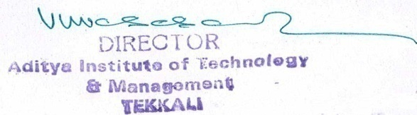
_______________________________

Signature of the Coordinator, IQAC Signature of the Chairperson, IQAC
_______***_______
Annexure I

Abbreviations:
CAS - Career Advanced Scheme
CAT - Common Admission Test
CBCS - Choice Based Credit System
CE - Centre for Excellence
COP - Career Oriented Programme
CPE - College with Potential for Excellence
DPE - Department with Potential for Excellence
GATE - Graduate Aptitude Test
NET - National Eligibility Test
PEI - Physical Education Institution
SAP - Special Assistance Programme
SF - Self Financing
SLET - State Level Eligibility Test
TEI - Teacher Education Institution
UPE - University with Potential Excellence
UPSC - Union Public Service Commission

***************

Annexure-I

Feedback Questions
  - Theory:

- Teacher comes to class on time
- Teaching is well planned
- Teacher makes objectives clear
- Subject matters are organized in logical sequence
- Teacher comes well prepared in the subject
- Teacher speaks clearly and audibly
- Teacher writes and draws visibly
- Teacher explains with examples clearly
- Teaching pace is good, not very fast
- Teacher offers assistance and counselling.
- Teacher asks relevant questions for interaction
- Teacher encourages raising doubts
- Teacher ensures learning of subject
- Teacher encourages originality and creativity
- Teacher is courtesies and impartial
- Teacher is regular and maintains discipline
- Teacher covers the syllabus at appropriate pace
- Teacher holds quizzes, Seminars regularly
- Teacher correction of scripts is fair and impartial
- Faculty uploading their course material in E-Portal or not.

  - Labs:
- Are you satisfied with your batch Size?
- Are the experiments of the Lab Classes conducted as per schedule provided?
- Are the Equipment’s provided sufficient?
- Are the Equipment’s provided in working condition?
- Are the Lab Consumables provided of Good Quality?
- Are the experiments were conducted over and Above the Syllabus?
- The Lab Manual Provided was complete in covering the Syllabus and informative
- Whether the lab assistant/technician are assisting you
- Whether the lab in-charges (Faculties) are helpful in the Lab

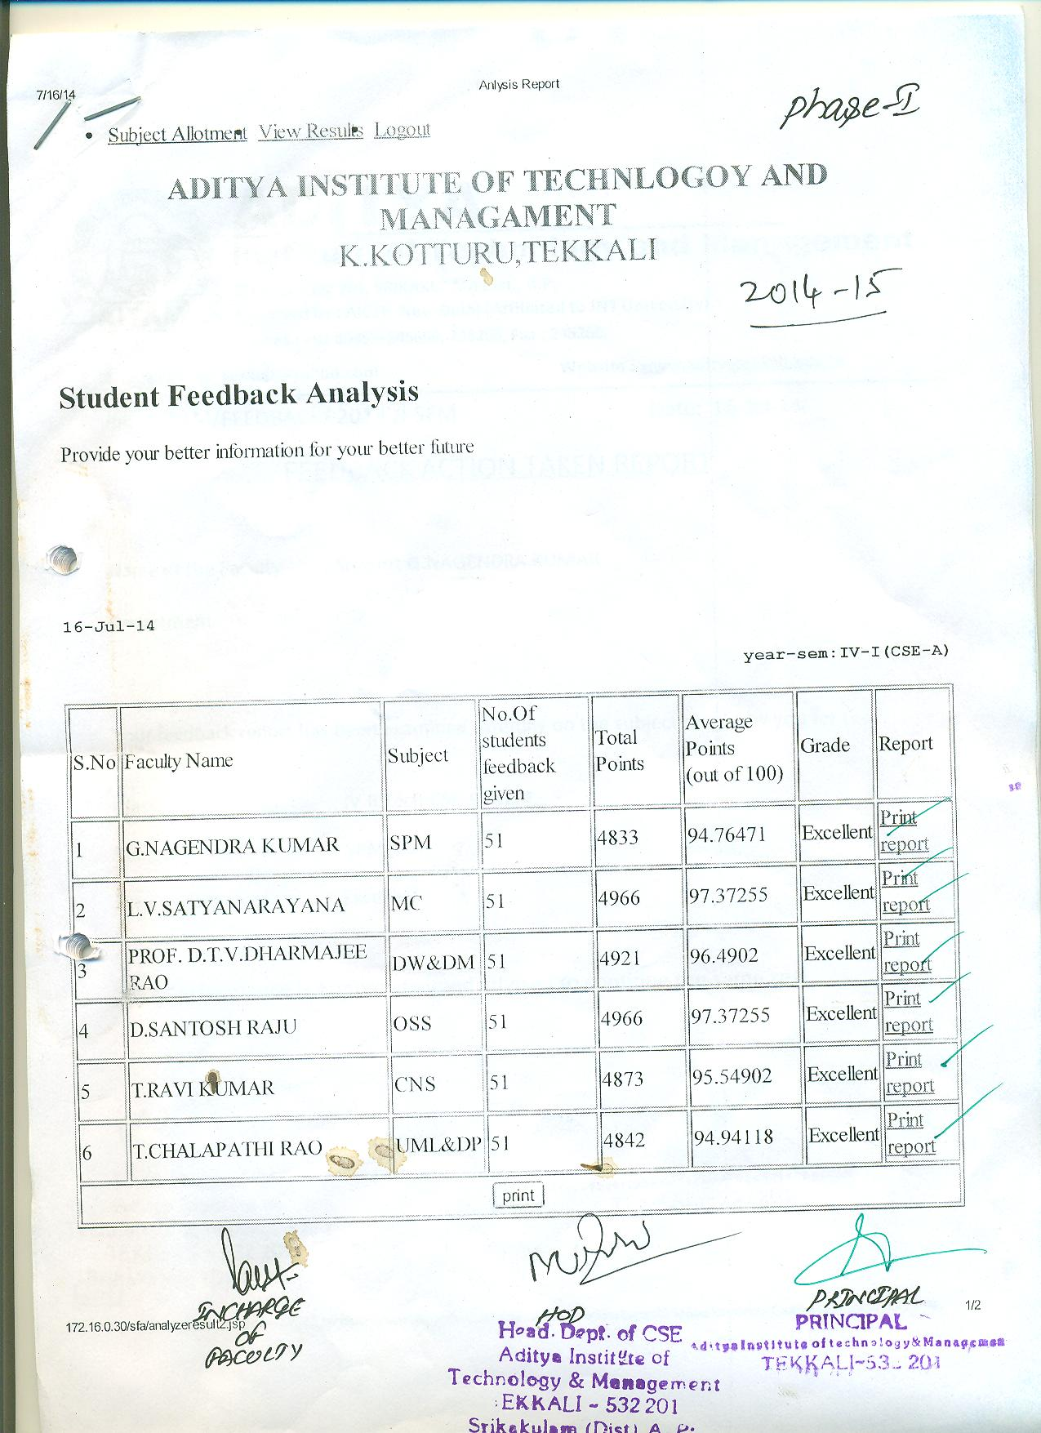
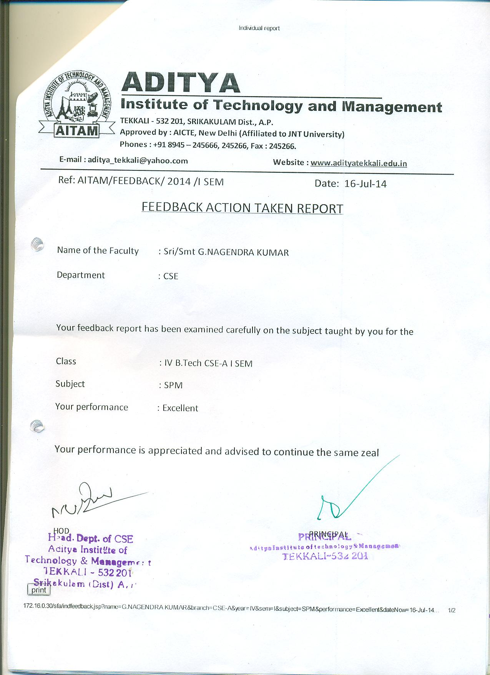
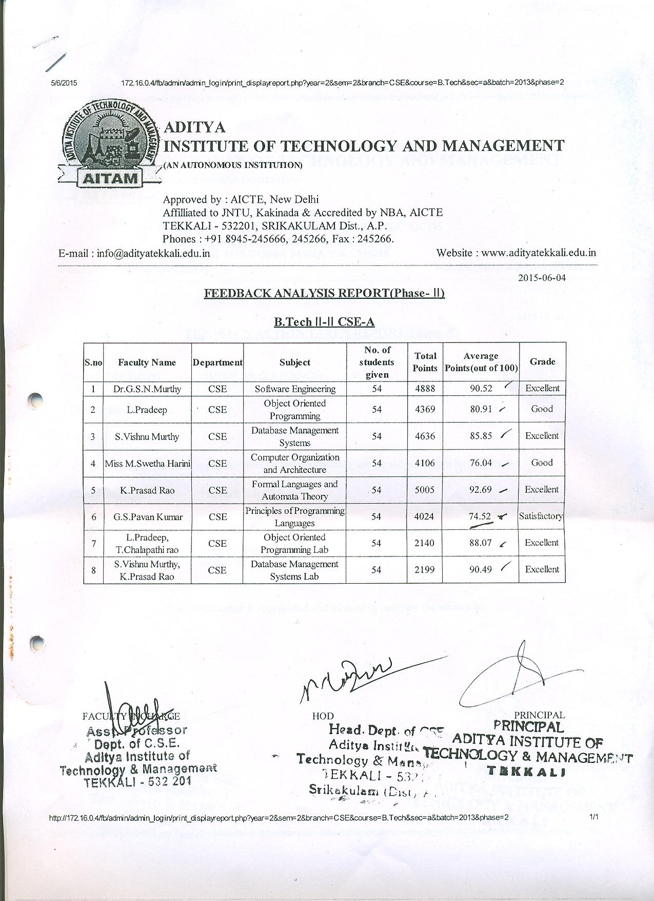
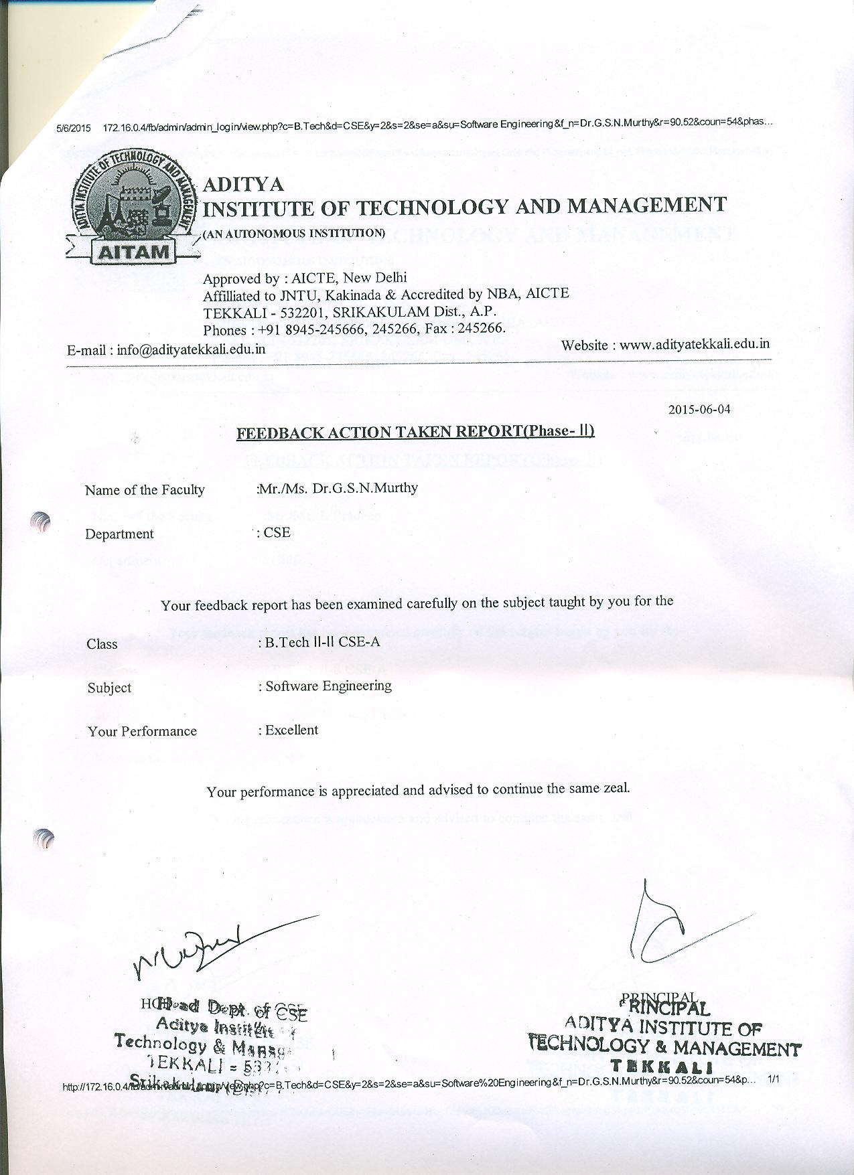

Alumni Feedback

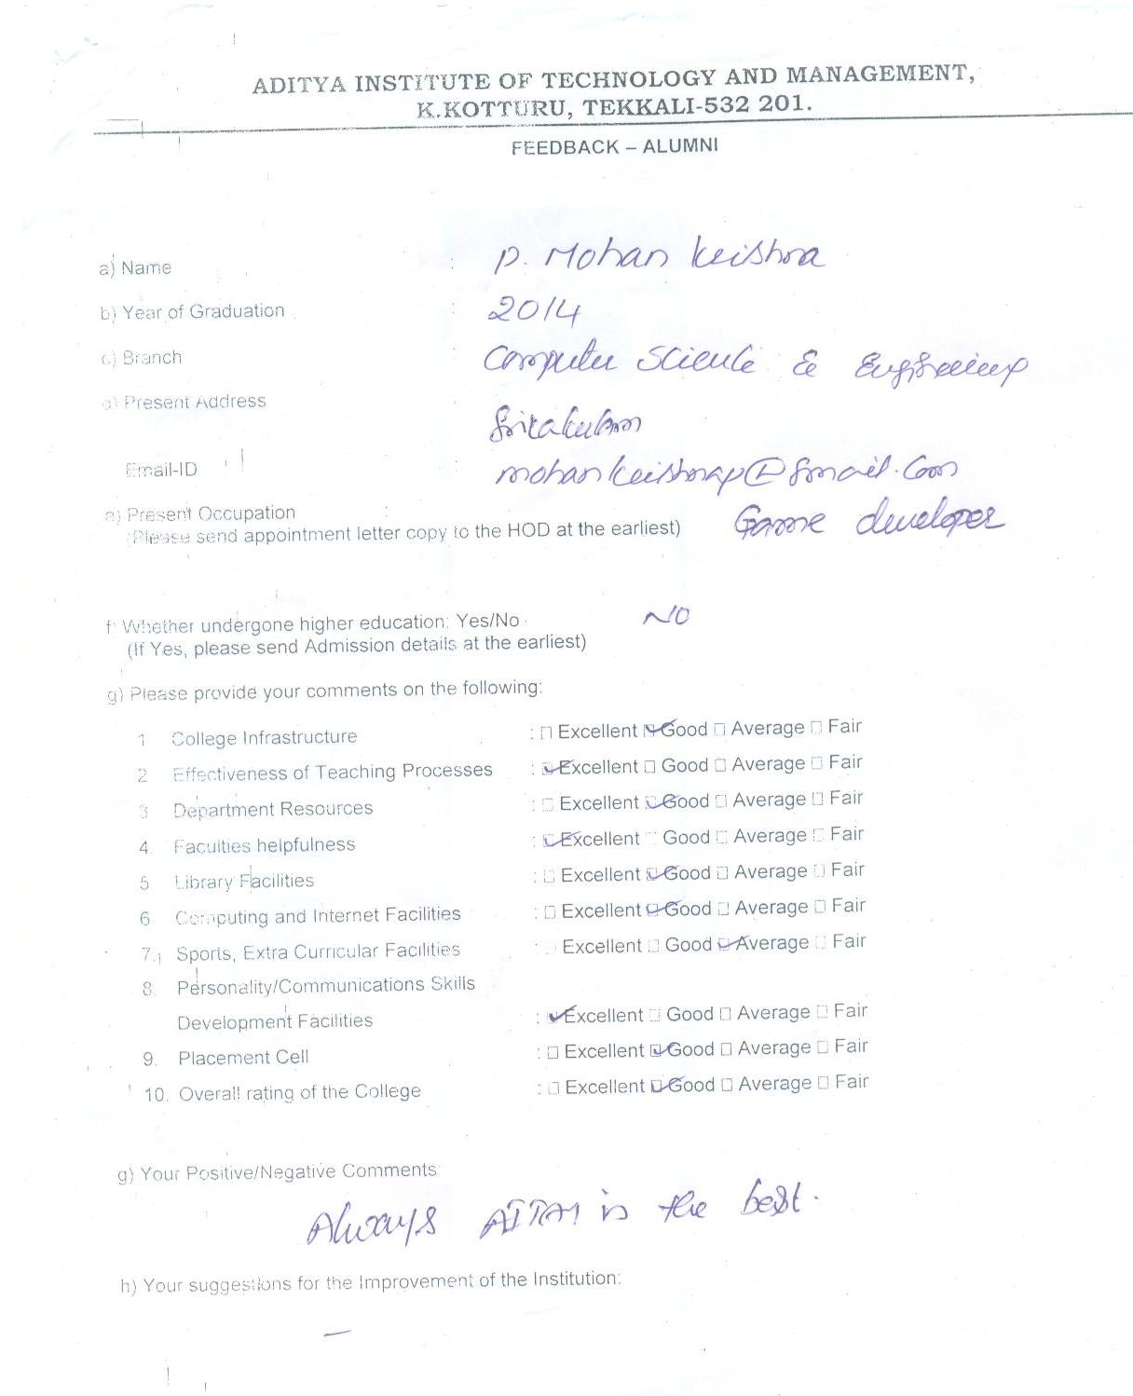

Parents Feedback
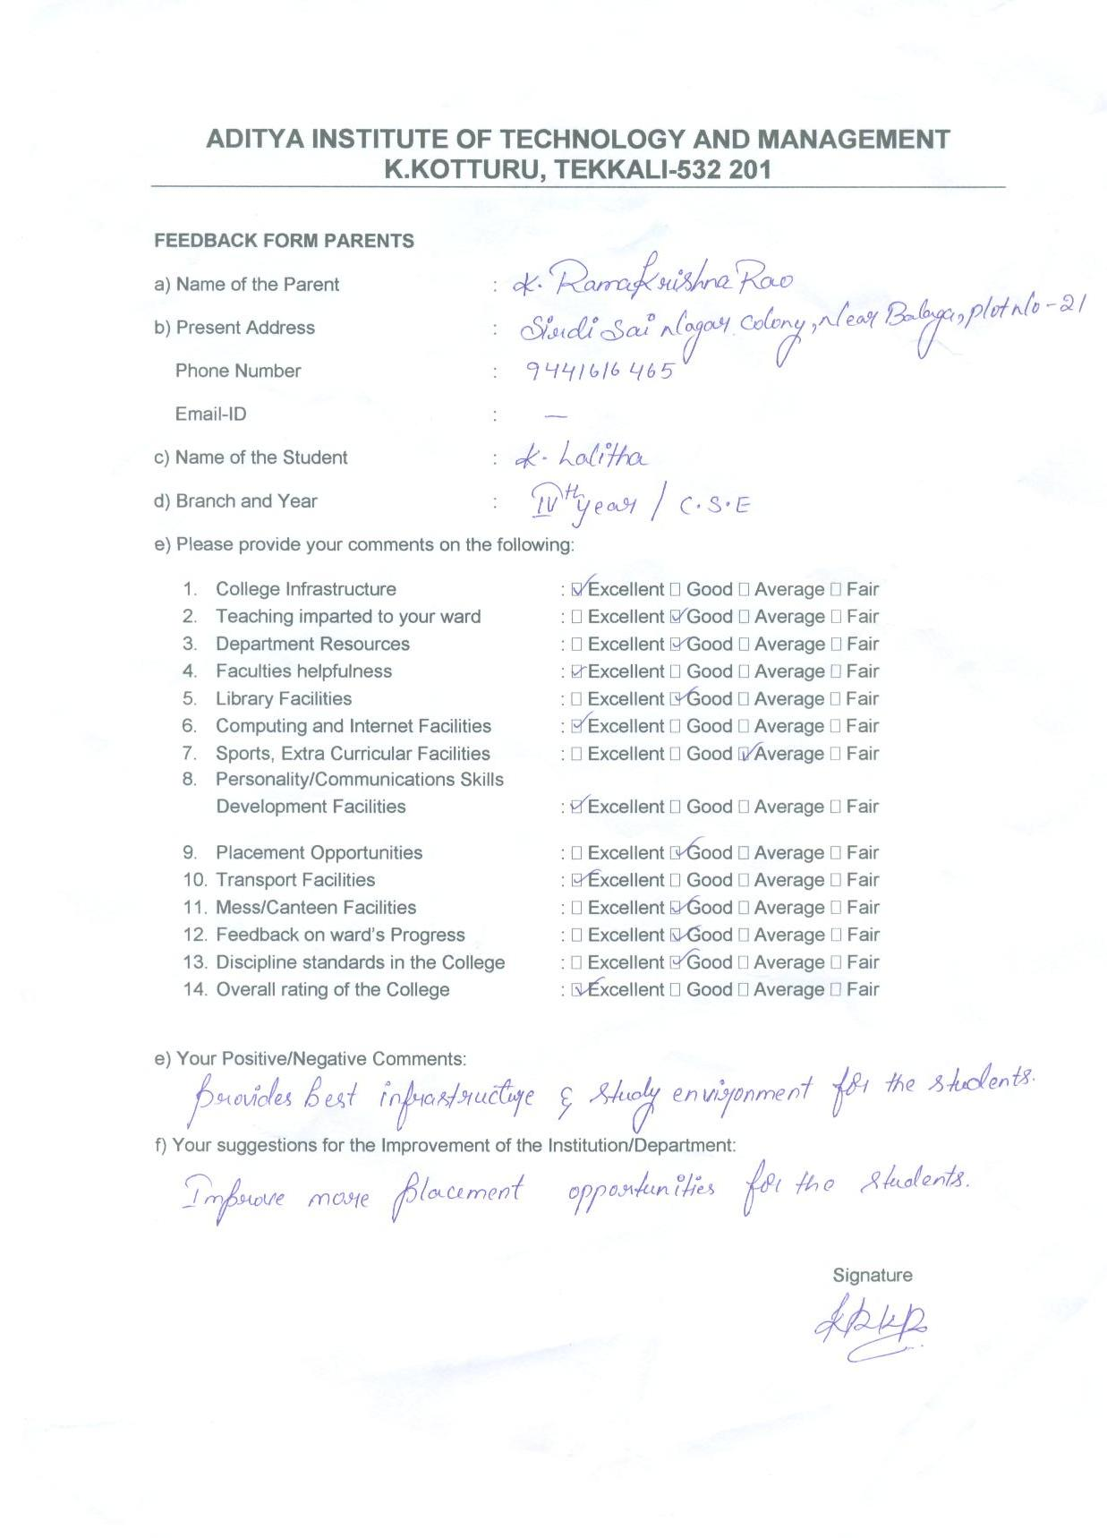

Annexure-II

ACADEMIC CALENDAR
June 2014
DAY | DATE | EVENT
SUN | 1 | HOLIDAY
MON | 2 | B. Tech 1st Year 2nd Sem Practical End Examinations &  Preparation Holidays (Autonomous)
TUE | 3
WED | 4
THU | 5
FRI | 6
SAT | 7
SUN | 8 | HOLIDAY
MON | 9 | B. Tech 1st Year 2nd Sem End Examinations (Autonomous)
TUE | 10
WED | 11
THU | 12
FRI | 13
SAT | 14 | HOLIDAY (2nd Saturday)
SUN | 15 | HOLIDAY
MON | 16 | B. Tech 4th Year 1st Sem Class Work Commenced &  B. Tech 1st Year 2nd Sem End Examinations (Autonomous)
TUE | 17
WED | 18
THU | 19
FRI | 20 | B. Tech 1st Year 2nd Sem End Examinations (Autonomous) &  A One Day Workshop on Outcome Based Education
SAT | 21 | B. Tech 1st Year 2nd Sem End Examinations (Autonomous)
SUN | 22 | HOLIDAY
MON | 23 | B. Tech 1st Year 2nd Sem (Autonomous) 2nd MID Examinations &  Summer Vacation for 2nd B. Tech
TUE | 24 | B. Tech 1st Year 2nd Sem (Autonomous) 2nd MID Examinations &  Summer Vacation for 2nd B. Tech
WED | 25 | B. Tech 1st Year 2nd Sem (Autonomous) 2nd MID Examinations &  Summer Vacation for 2nd B. Tech
THU | 26
FRI | 27
SAT | 28
SUN | 29 | HOLIDAY
MON | 30
July 2014
DAY | DATE | EVENTS
TUE | 1
WED | 2
THU | 3
FRI | 4
SAT | 5
SUN | 6 | HOLIDAY
MON | 7
TUE | 8
WED | 9
THU | 10
FRI | 11
SAT | 12 | HOLIDAY (2nd Saturday)
SUN | 13 | HOLIDAY
MON | 14 | Remedial Classes for B. Tech 1st Year Students (Autonomous)
TUE | 15
WED | 16
THU | 17
FRI | 18
SAT | 19
SUN | 20 | HOLIDAY
MON | 21
TUE | 22
WED | 23
THU | 24
FRI | 25
SAT | 26
SUN | 27 | HOLIDAY
MON | 28 | HOLIDAY (Id-Ul-Fitr)
TUE | 29
WED | 30
THU | 31 | B. Tech 1st Year 2nd Sem (Autonomous) 3rd MID Examinations
August 2014
DAY | DATE | EVENT
FRI | 1 | B. Tech 1st Year 2nd Sem (Autonomous) 3rd MID Examinations
SAT | 2 | B. Tech 1st Year 2nd Sem (Autonomous) 3rd MID Examinations
SUN | 3 | HOLIDAY
MON | 4 | B. Tech 1st Year 2nd Sem (Autonomous) Preparation Holidays for end examinations
TUE | 5
WED | 6
THU | 7
FRI | 8
SAT | 9 | HOLIDAY (2nd Saturday)
SUN | 10 | HOLIDAY
MON | 11 | B. Tech 1st Year 2nd Sem (Autonomous) End Examinations
TUE | 12
WED | 13
THU | 14
FRI | 15 | HOLIDAY (Independence Day)
SAT | 16 | B. Tech 1st Year 2nd Sem (Autonomous) End Examinations
SUN | 17 | HOLIDAY (Krishna Janmastami) &  A One Day Workshop on Outcome Based Education
MON | 18
TUE | 19 | B. Tech 1st Year 2nd Sem (Autonomous) End Examinations
WED | 20
THU | 21
FRI | 22
SAT | 23
SUN | 24 | HOLIDAY
MON | 25 | B. Tech 3rd Class Work Commenced &  B. Tech 1st Year 2nd Sem (Autonomous) Practical End Examinations
TUE | 26 | B. Tech 1st Year 2nd Sem (Autonomous) Practical End Examinations
WED | 27
THU | 28
FRI | 29 | HOLIDAY (Ganesh Chaturthi)
SAT | 30 | B. Tech 1st Year 2nd Sem (Autonomous) Practical End Examinations
SUN | 31 | HOLIDAY
September 2014
DAY | DATE | EVENT
MON | 1
TUE | 2
WED | 3
THU | 4
FRI | 5
SAT | 6
SUN | 7 | HOLIDAY
MON | 8
TUE | 9 | B. Tech 2nd Year 1st Sem (Autonomous) Class Works Commenced &  A Six Day Skill Development Training Programme on Advance Surveying Techniques using Total Station GPS organized by Civil Dept.  (9th to 14th Sep, 2014)
WED | 10
THU | 11
FRI | 12
SAT | 13 | HOLIDAY (2nd Saturday)
SUN | 14 | HOLIDAY
MON | 15 | B. Tech 1st Year 1-Sem (Autonomous) Class Work Commenced
TUE | 16
WED | 17
THU | 18
FRI | 19 | Three Day Training Programme on “SPSS Hands on Experience”  by Dept. (19th to 21st Sep, 2014)
SAT | 20
SUN | 21
MON | 22 | MCA 4th Sem 2nd MID Exams &  A Three Week Training Programme on “Geospatial Data and Its Applications” by Civil Dept. (22nd Sep to 12th Oct, 2014)
TUE | 23 | MCA 4th Sem 2nd MID Exams
WED | 24 | MCA 4th Sem 2nd MID Exams
THU | 25 | MCA 4th Sem 2nd MID Exams & MBA 4th Sem MID Exams
FRI | 26 | MCA 4th Sem 2nd MID Exams & MBA 4th Sem MID Exams
SAT | 27 | MBA 4th Sem MID Exams
SUN | 28 | HOLIDAY
MON | 29 | MBA 4th Sem 2MID Exams
TUE | 30
October 2014
DAY | DATE | EVENT
WED | 1
THU | 2 | HOLIDAY (Mahatma Gandhi Jayanthi)
FRI | 3 | Dussehra Holidays
SAT | 4
SUN | 5
MON | 6 | MBA 3rd Sem 1st MID Exams
TUE | 7 | MBA 3rd Sem 1st MID Exams &  Remedial Classes for B. Tech 2nd Year 1st Sem (Autonomous) ECE Students
WED | 8 | MBA 3rd Sem 1st MID Exams &  Remedial Classes for B. Tech 2nd Year 1st Sem (Autonomous) ECE Students
THU | 9 | B. Tech 2nd Year 1st Sem (Autonomous) 1st MID &  3rd Sem MBA 1st MID Exams
FRI | 10
SAT | 11
SUN | 12 | HOLIDAY
MON | 13 | B. Tech 2nd Year 1st Sem (Autonomous) Intra Sem Break &  MBA 1st Sem Class Work Start
TUE | 14 | B. Tech 2nd Year 1st Sem (Autonomous) Intra Sem Break
WED | 15
THU | 16
FRI | 17
SAT | 18
SUN | 19
MON | 20
TUE | 21
WED | 22
THU | 23
FRI | 24 | Diwali
SAT | 25 | Muharram
SUN | 26 | HOLIDAY
MON | 27 | B. Tech 3rd Year 1st Sem JNTU 1st MID & Online Exams
TUE | 28
WED | 29
THU | 30
FRI | 31
November 2014
DAY | DATE | EVENT
SAT | 1
SUN | 2 | HOLIDAY
MON | 3 | B. Tech 4th Year 1st Sem JNTU 2nd MID & Online Exams
TUE | 4
WED | 5
THU | 6
FRI | 7
SAT | 8 | HOLIDAY (2nd Saturday)
SUN | 9 | HOLIDAY
MON | 10 | B. Tech 1st Year 1st Sem (Autonomous) 1st MID Exams
TUE | 11 | B. Tech 1st Year 1st Sem (Autonomous) 1st MID Exams &  Remedial Classes for B. Tech 2nd Year 1st Sem (Autonomous) ECE Students
WED | 12 | B. Tech 1st Year 1st Sem (Autonomous) 1st MID Exams
THU | 13
FRI | 14
SAT | 15
SUN | 16 | HOLIDAY
MON | 17 | M. Tech 1st Year 1st Sem (Autonomous) Class Work Start
TUE | 18
WED | 19
THU | 20
FRI | 21
SAT | 22 | Makeup Classes for B. Tech 3rd Year 1st Sem ECE A & B Students  & Industrial Tour for B. Tech 3rd Year 1st Sem ECE (Steel Plant at Visakhapatnam)
SUN | 23 | HOLIDAY
MON | 24
TUE | 25
WED | 26
THU | 27
FRI | 28
SAT | 29 | Remedial Classes for B. Tech 3rd Year 1st Sem CSE Students
SUN | 30 | HOLIDAY
December 2014
DAY | DATE | EVENT
MON | 1 | B. Tech 4th Year 2nd Sem Class Work Starts, MBA 1st Sem 1st MID Exams & 3rd Sem MBA 2nd MID Exams
TUE | 2 | 1st Sem MBA (Autonomous) 1st MID Exams &  3rd Sem MBA 2nd MID Exams
WED | 3 | B. Tech 2nd Year 1st Sem (Autonomous) 2nd MID Exams,  1st Sem MBA 1st MID Exams & 3rd Sem MBA 2nd MID Exams
THU | 4
FRI | 5
SAT | 6 | Makeup Classes for B. Tech 3rd Year 1st Sem ECE Students  & Remedial Classes for B. Tech 3rd Year 1st Sem CSE Students
SUN | 7 | HOLIDAY
MON | 8
TUE | 9
WED | 10 | B. Tech 1st Year 1st Sem (Autonomous) 2nd MID Exams
THU | 11
FRI | 12
SAT | 13 | Remedial Classes for B. Tech 3rd Year 1st Sem CSE Students  & Industrial Tour for B. Tech 2nd Year 1st Sem CSE-A (Millennium, Software, Visakhapatnam)
SUN | 14 | HOLIDAY
MON | 15 | B. Tech 3rd Year 1st Sem JNTU 2nd MID & Online Exams,  3rd Sem MBA External Exams (Autonomous) &  Two Day Workshop on “Software Engineering and Allied Tools” by CSE (15th & 16th Dec, 2014)
TUE | 16 | B. Tech 3rd Year 1st Sem JNTU 2nd MID & Online Exams &  A One Day Workshop on Outcome Based Education
WED | 17 | B. Tech 3rd Year 1st Sem JNTU 2nd MID & Online Exams,  3rd Sem MBA External Exams (Autonomous)
THU | 18 | B. Tech 3rd Year 1st Sem JNTU 2nd MID & Online Exams
FRI | 19 | B. Tech 3rd Year 1st Sem JNTU 2nd MID & Online Exams &  3rd Sem MBA External Exams (Autonomous)
SAT | 20 | B. Tech 3rd Year 1st Sem JNTU 2nd MID & Online Exams &  Industrial Tour for B. Tech 2nd Year 1st Sem CSE-B (Media3 International Soft Solution, Visakhapatnam)
SUN | 21 | HOLIDAY
MON | 22 | MBA 3rd Sem External Exams (Autonomous)
TUE | 23
WED | 24 | MBA 3rd Sem External Exams (Autonomous)
THU | 25 | HOLIDAY (Christmas)
FRI | 26 | MBA 3rd Sem External Exams (Autonomous)
SAT | 27 | Makeup Classes for B. Tech 3rd Year 1st Sem ECE Students
SUN | 28 | HOLIDAY
MON | 29 | MBA 4th Sem Class Work Start (Autonomous)
TUE | 30
WED | 31
January 2015
DAY | DATE | EVENT
THU | 1 | NEW YEAR HOLIDAY
FRI | 2 | MBA 1st MID Exams (Autonomous)
SAT | 3
SUN | 4 | HOLIDAY & Industrial Tour for B. Tech 4th Year 2nd Sem ECE-B
MON | 5 | MBA 1st 1st MID Exams (Autonomous)
TUE | 6
WED | 7 | B. Tech 2nd Year 1st Sem Projects and Practicals &  1st M. Tech 1st Sem 1st MID Exams (Autonomous)
THU | 8
FRI | 9
SAT | 10 | B. Tech 2nd Year 1st Sem (Autonomous) 3rd MID Exams &  Industrial Tour for B. Tech 4th Year 2nd Sem CSE-A & B (Media3 International Soft Solution, Visakhapatnam)
SUN | 11 | B. Tech 2nd Year 1st Sem (Autonomous) 3rd MID Exams &  Industrial Tour for B. Tech 4th Year 2nd Sem IT (Media 3 International Soft Solution, at Visakhapatnam)
MON | 12 | B. Tech 2nd Year 1st Sem (Autonomous) 3rd MID Exams
TUE | 13 | HOLIDAYS (Pongal)
WED | 14
THU | 15
FRI | 16
SAT | 17
SUN | 18
MON | 19 | MCA 5th Sem 1st MID Exams & B. Tech 1st Year 1st Sem (Autonomous) 3rd MID, B. Tech 2nd Year 1st Sem (Autonomous) External Exams &  B. Tech 3rd Year 2nd Sem Class Work Start
TUE | 20 | MCA 5th Sem 1st MID Exams &  B. Tech 1st Year 1st Sem (Autonomous) 3rd MID
WED | 21 | MCA 5th Sem 1st MID Exams &  B. Tech 1st Year 1st Sem (Autonomous) 3rd MID &  B. Tech 2nd Year 1st Sem (Autonomous) External Exams
THU | 22 | MCA 5th Sem 1st MID Exams &  B. Tech 1st Year 1st Sem (Autonomous) Projects and Practicals
FRI | 23 | MCA 5th Sem 1st MID Exams &  B. Tech 1st Year 1st Sem (Autonomous) Projects and Practicals &  B. Tech 2nd Year 1st Sem External Exams (Autonomous)
SAT | 24 | MCA 5th Sem 1st MID Exams &  B. Tech 1st Year 1st Sem (Autonomous) Projects and Practicals
SUN | 25 | HOLIDAY
MON | 26 | HOLIDAY (Republic Day)
TUE | 27 | B. Tech 4th Year 2nd Sem JNTUK 1st MID & Online Exams & B. Tech 2nd Year 1st Sem (Autonomous) External Exams & MBA 1st Sem 2nd MID Exams (Autonomous)
WED | 28 | B. Tech 4th Year 2nd Sem JNTUK 1st MID & Online Exams & B. Tech 2nd Year 1st Sem (Autonomous) External Exams & MBA 1st Sem 2nd MID Exams (Autonomous)
THU | 29 | B. Tech 4th Year 2nd Sem JNTUK 1st MID & Online Exams & B. Tech 1st Year 1st Sem (Autonomous) External Exams & B. Tech 2nd Year 1st Sem (Autonomous) External Exams & MBA 1st Sem 2nd MID Exams (Autonomous)
FRI | 30 | B. Tech 4th Year 2nd Sem JNTU 1st MID & Online Exams & B. Tech 1st Year 1st Sem (Autonomous) External Exams & MBA 1st Sem 2nd MID Exams (Autonomous)
SAT | 31 | B. Tech 4th Year 2nd Sem JNTU 1st MID & Online Exams &  B. Tech 1st Year 1st Sem (Autonomous) External Exams & B. Tech 2nd Year 1st Sem (Autonomous) External Exams &  MBA 1st Sem 2nd MID Exams (Autonomous)
February 2015
DAY | DATE | EVENT
SUN | 1 | HOLIDAY
MON | 2 | B. Tech 1st Year 1st Sem External Exams & B. Tech 2nd Year 2nd Sem Class Work Start (Autonomous) &  Industrial Tour (HPCL-VSKP) for IV ME
TUE | 3 | B. Tech 4th Year 2nd Sem JNTUK 1st MID & Online Exams (only for Civil Engineering)
WED | 4 | B. Tech 4th Year 2nd Sem JNTUK 1st MID & Online Exams (only for ECE) &  B. Tech 1st Year 1st Sem External Exams (Autonomous)
THU | 5
FRI | 6 | B. Tech 1st Year 1st Sem External Exams (Autonomous)
SAT | 7 | Industrial Tour for B. Tech 4th Year 2nd Sem ECE  (Radar Station at Visakhapatnam) & Industrial Tour for B. Tech 4th Year 2nd Sem ME-A (Hindustan Ship Yard, VSP)
SUN | 8 | HOLIDAY
MON | 9 | MBA 1st Year 1st Sem External Exams (Autonomous)
TUE | 10
WED | 11 | B. Tech 1st Year 1st Sem External Exams &  MBA 1st Year 1st Sem External Exams (Autonomous)
THU | 12 | B. Tech 1st Year 2nd Sem Class Work Start (Autonomous)
FRI | 13 | Industrial Tour for B. Tech 3rd Year 2nd Sem ECE  (Radar Station at Visakhapatnam)
SAT | 14 | HOLIDAY (2nd Saturday)
SUN | 15 | HOLIDAY
MON | 16 | MBA 1st Sem External Exams (Autonomous) &  MBA 4th Sem 1st MID Exams
TUE | 17 | Mahashivratri & MBA 4th Sem 1st MID Exams
WED | 18 | MBA 1st Sem External Exams (Autonomous) &  MBA 4th Sem 1st MID Exams
THU | 19 | MBA 4th Sem 1st MID Exams
FRI | 20 | MBA 4th Sem 1st MID Exams &  Two Day Workshop ESPACE-2K15 by ECE Dept.  (20th & 21st Feb, 2015)
SAT | 21 | MBA 1st Sem External Exams (Autonomous)
SUN | 22 | HOLIDAY
MON | 23 | MBA 2nd Sem Class Work Start (Autonomous)
TUE | 24
WED | 25
THU | 26
FRI | 27
SAT | 28

March 2015
DAY | DATE | EVENT
SUN | 1 | HOLIDAY
MON | 2 | MCA 4th Sem Class Work Start & 1st M. Tech 2nd MID Exams &  B. Tech 2nd Year 2nd Sem Intra Sem Break (Autonomous)
TUE | 3 | 1st M. Tech 2nd MID Exams &  B. Tech 2nd Year 2nd Sem Intra Sem Break (Autonomous)
WED | 4
THU | 5
FRI | 6 | Holi-HOLIDAY
SAT | 7 | B. Tech 2nd Year 2nd Sem Intra Sem Break,  Remedial Classes for B. Tech 2nd Year 2nd Sem EEE &  Industrial Tour for IV EEE-B, (Steel Plant, VSP) &  A Two Day National Workshop on GIS Applications for Public Health Protection organized by Civil Dept. (7th & 8th March, 2015)
SUN | 8 | HOLIDAY
MON | 9 | B. Tech 3rd Year 2nd Sem JNTUK 1st MID & Online Exams & B. Tech 1st Year 2nd Sem (Autonomous) &  B. Tech 2nd Year 2nd Sem Intra Sem Break (Autonomous),  A One Day Workshop on Outcome Based Education
TUE | 10 | B. Tech 3rd Year 2nd Sem JNTUK 1st MID & Online Exams & B. Tech 1st Year 2nd Sem (Autonomous) &  B. Tech 2nd Year 2nd Sem Intra Sem Break (Autonomous)
WED | 11 | B. Tech 3rd Year 2nd Sem JNTUK 1st MID & Online Exams & B. Tech 1st Year 2nd Sem (Autonomous) &  B. Tech 2nd Year 2nd Sem Intra Sem Break (Autonomous)
THU | 12 | B. Tech 3rd Year 2nd Sem JNTUK 1st MID & Online Exams & B. Tech 1st Year 2nd Sem (Autonomous) &  B. Tech 2nd Year 2nd Sem Intra Sem Break (Autonomous)
FRI | 13 | B. Tech 3rd Year 2nd Sem JNTUK 1st MID & Online Exams & B. Tech 1st Year 2nd Sem (Autonomous) &  B. Tech 2nd Year 2nd Sem Intra Sem Break (Autonomous)
SAT | 14 | B. Tech 3rd Year 2nd Sem JNTUK 1st MID & Online Exams & B. Tech 1st Year 2nd Sem (Autonomous) &  B. Tech 2nd Year 2nd Sem Intra Sem Break (Autonomous) &  Industrial Tour for IV EEE-A (Solar Panel Constructive Plant, VSP),  Industrial Tour for 4th Year 2nd Sem ME-B (NTD Testing, VSP) &  Industrial Tour for 4th Year 2nd Sem Civil (Navy Quarters)
SUN | 15 | HOLIDAY
MON | 16 | 1st M. Tech 1st Sem External Exams &  B. Tech 1st Year 2nd Sem Intra Sem Break (Autonomous)
TUE | 17 | B. Tech 1st Year 2nd Sem Intra Sem Break (Autonomous)
WED | 18 | 1st M. Tech 1st Sem External Exams &  B. Tech 1st Year 2nd Sem Intra Sem Break (Autonomous)
THU | 19 | B. Tech 1st Year 2nd Sem Intra Sem Break (Autonomous)
FRI | 20 | 1st M. Tech 1st Sem External Exams &  B. Tech 1st Year 2nd Sem Intra Sem Break (Autonomous)
SAT | 21 | Uagadi-HOLIDAY
SUN | 22 | HOLIDAY
MON | 23 | 1st M. Tech 1st Sem External Exams (Autonomous)
TUE | 24
WED | 25 | 1st M. Tech 1st Sem External Exams (Autonomous)
THU | 26 | B. Tech 2nd Year 2nd Sem 1st MID Exams (Autonomous)
FRI | 27 | B. Tech 2nd Year 2nd Sem 1st MID Exams (Autonomous)
SAT | 28 | 1st M. Tech 1st Sem External Exams &  B. Tech 2nd Year 2nd Sem 1st MID Exams (Autonomous)
SUN | 29 | HOLIDAY &  AICTE Sponsored National Conference on “Emerging Challenges in Finance” by MBA Dept. (29th to 31st March, 2015)
MON | 30 | B. Tech 4th Year 2nd Sem JNTUK 2nd MID & Online Exams
TUE | 31 | B. Tech 4th Year 2nd Sem JNTUK 2nd MID & Online Exams

April 2015
DAY | DATE | EVENT
WED | 1 | B. Tech 4th Year 2nd Sem JNTUK 2nd MID & Online Exams &  Long Industrial Tour for B. Tech 3rd Year 2nd Sem ME,  Industrial Tour for B. Tech 4th Year 2nd Sem ECE (Radar Station at Visakhapatnam), Industrial Tour for B. Tech 4th Year 2nd Sem Civil (Metro Line, Bangalore & Tea Factory, Ooty)
THU | 2 | B. Tech 4th Year 2nd Sem JNTUK 2nd MID & Online Exams &  Industrial Tour for B. Tech 4th Year 2nd Sem Civil (Metro Line, Bangalore & Tea Factory, Ooty)  Long Industrial Tour for B. Tech 3rd Year 2nd Sem ME
FRI | 3 | Long Industrial Tour for B. Tech 3rd Year 2nd Sem CSE, IT (Radio Astronomy Centre-Ooty), Long Industrial Tour for B. Tech 3rd Year 2nd Sem ECE (Radio Telescope, Ooty), Industrial Tour for B. Tech 4th Year 2nd Sem Civil (Metro Line, Bangalore & Tea Factory, Ooty)  ME, EEE
SAT | 4 | B. Tech 4th Year 2nd Sem JNTUK 2nd MID & Online Exams (only for Civil),  Long Industrial Tour for B. Tech 3rd Year 2nd Sem CSE, IT (Radio Astronomy Centre-Ooty), Long Industrial Tour for B. Tech 3rd Year 2nd Sem ECE (Radio Telescope, Ooty) & Industrial Tour for B. Tech 4th Year 2nd Sem Civil (Metro Line, Bangalore & Tea Factory, Ooty), Long Industrial Tour for B. Tech 3rd Year 2nd Sem ME, EEE,  Makeup Classes for B. Tech 2nd Year 1st Sem ECE Students (Autonomous) &  Five Day Workshop on Effective Solutions to Smart Grid organized by EEE Dept. (4th to 8th Apr, 2015)
SUN | 5 | HOLIDAY &  Long Industrial Tour for B. Tech 3rd Year 2nd Sem CSE, IT (Radio Astronomy Centre-Ooty), Long Industrial Tour for B. Tech 3rd Year 2nd Sem ECE (Radio Telescope, Ooty) & Industrial Tour for B. Tech 4th Year 2nd Sem Civil (Metro Line, Banglore & Tea Factory, Ooty), Long Industrial Tour for B. Tech 3rd Year 2nd Sem ME
MON | 6 | B. Tech 4th Year 2nd Sem JNTUK 2nd MID & Online Exams (only for ECE) &  Long Industrial Tour for B. Tech 3rd Year 2nd Sem CSE, IT (Radio Astronomy Centre-Ooty), Long Industrial Tour for B. Tech 3rd Year 2nd Sem ECE (Radio Telescope, Ooty), Industrial Tour for B. Tech 4th Year 2nd Sem Civil (Metro Line, Bangalore & Tea Factory, Ooty) & Long Industrial Tour for B. Tech 3rd Year 2nd Sem ME, EEE
TUE | 7 | Long Industrial Tour for B. Tech 3rd Year 2nd Sem CSE, IT (Radio Astronomy Centre-Ooty), Long Industrial Tour for B. Tech 3rd Year 2nd Sem ECE (Radio Telescope, Ooty), Industrial Tour for B. Tech 4th Year 2nd Sem Civil (Metro Line, Bangalore & Tea Factory, Ooty) & Long Industrial Tour for B. Tech 3rd Year 2nd Sem ME, EEE
WED | 8 | Long Industrial Tour for B. Tech 3rd Year 2nd Sem CSE, IT (Radio Astronomy Centre-Ooty), Long Industrial Tour for B. Tech 3rd Year 2nd Sem ECE (Radio Telescope, Ooty), Industrial Tour for B. Tech 4th Year 2nd Sem Civil (Metro Line, Bangalore & Tea Factory, Ooty) & Long Industrial Tour for B. Tech 3rd Year 2nd Sem ME, EEE
THU | 9 | Long Industrial Tour for B. Tech 3rd Year 2nd Sem CSE, IT (Radio Astronomy Centre-Ooty), Long Industrial Tour for B. Tech 3rd Year 2nd Sem ECE (Radio Telescope, Ooty), Industrial Tour for B. Tech 4th Year 2nd Sem Civil (Metro Line, Bangalore & Tea Factory, Ooty) & Long Industrial Tour for B. Tech 3rd Year 2nd Sem ME, EEE &  B. Tech 1st Year 2nd Sem 1st MID Exams (Autonomous)
FRI | 10 | B. Tech 1st Year 2nd Sem 1st MID Exams &  Long Industrial Tour for B. Tech 3rd Year 2nd Sem CSE, IT (Radio Astronomy Centre-Ooty), Long Industrial Tour for B. Tech 3rd Year 2nd Sem ECE (Radio Telescope, Ooty) &  B. Tech 2nd Year 2nd Sem Industrial Tour for Civil (Shipyard, Visakhapatnam) &  Long Industrial Tour for B. Tech 3rd Year 2nd Sem Civil, ME, EEE
SAT | 11 | B. Tech 1st Year 2nd Sem 1st MID Exams
SUN | 12 | HOLIDAY
MON | 13 | MBA 2nd Sem 1st MID Exams &  B. Tech 2nd Year 4th Sem 2nd MID Exams (Autonomous)
TUE | 14 | Dr. B.R. Ambekar Jayathi-Holiday
WED | 15 | MBA 2nd Sem 1st MID Exams &  B. Tech 2nd Year 4th Sem 2nd MID Exams (Autonomous)
THU | 16
FRI | 17
SAT | 18 | MBA 2nd Sem 1st MID Exams &  B. Tech 2nd Year 4th Sem 2nd MID Exams (Autonomous) &  Makeup Classes for B. Tech 3rd Year 2nd Sem, B. Tech 2nd Year 2nd Sem ECE Students,  Remedial Classes for B. Tech 3rd Year 2nd Sem IT Students &  Industrial Tour for B. Tech 2nd Year 2nd Sem ECE-A (Radar Station at Visakhapatnam) (Autonomous), Industrial Tour for B. Tech 2nd Year 2nd Sem Civil (Narava Water Treatment Plant, VSP) ,  A One Day Workshop on Outcome Based Education
SUN | 19 | HOLIDAY
MON | 20
TUE | 21
WED | 22
THU | 23
FRI | 24
SAT | 25 | Industrial Tour for B. Tech 3rd Year 2nd Sem CSE-A & B (Millennium, Visakhapatnam), B. Tech 3rd Year 2nd Sem IT (Media 3 International Soft Solution, at Visakhapatnam),  B. Tech 2nd Year 2 Sem ECE (Radar Station at Visakhapatnam) (Autonomous),  B. Tech 3rd Year 2nd Sem EEE A & C (Solar Panel Constructive Plant, VSP), Makeup Classes for B. Tech 2nd Year 2nd Sem ECE-B Students (Autonomous) &  A One Day Workshop on Outcome Based Education
SUN | 26 | HOLIDAY
MON | 27
TUE | 28
WED | 29
THU | 30

May 2015
DAY | DATE | EVENT
FRI | 1
SAT | 2 | Industrial Tour for B. Tech 2nd Year 2nd Sem EEE-A, B & C (Steel Plant, VSKP) (Autonomous) &  B. Tech 3rd Year 2nd Sem EEE-B, (Mini Steel Plant, Duvvada, VSP)
SUN | 3 | HOLIDAY (Summer Vacation)
MON | 4 | HOLIDAY (Summer Vacation),  B. Tech 3rd Year 2nd Sem JNTUK 2nd MID & Online Exams
TUE | 5 | HOLIDAY (Summer Vacation)  B. Tech 3rd Year 2nd Sem JNTUK 2nd MID & Online Exams
WED | 6 | HOLIDAY (Summer Vacation)  B. Tech 3rd Year 2nd Sem JNTUK 2nd MID & Online Exams
THU | 7 | HOLIDAY (Summer Vacation)
FRI | 8 | HOLIDAY (Summer Vacation)
SAT | 9 | HOLIDAY (Summer Vacation)  B. Tech 3rd Year 2nd Sem JNTUK 2nd MID & Online Exams
SUN | 10 | HOLIDAY (Summer Vacation)  B. Tech 3rd Year 2nd Sem JNTUK 2nd MID & Online Exams
MON | 11 | HOLIDAY (Summer Vacation)  B. Tech 3rd Year 2nd Sem JNTUK 2nd MID & Online Exams
TUE | 12 | HOLIDAY (Summer Vacation)
WED | 13
THU | 14
FRI | 15
SAT | 16
SUN | 17
MON | 18 | B. Tech 3rd Year 2nd Sem JNTUK External Exams
TUE | 19
WED | 20 | B. Tech 3rd Year 2nd Sem JNTUK External Exams
THU | 21 | B. Tech 2nd Year 2nd Sem 2nd MID Exams
FRI | 22 | B. Tech 3rd Year 2nd Sem JNTUK External Exams &  B. Tech 2nd Year 2nd Sem 2nd MID Exams (Autonomous)
SAT | 23 | B. Tech 2nd Year 2nd Sem 2nd MID Exams (Autonomous)
SUN | 24 | HOLIDAY
MON | 25 | B. Tech 3rd Year 2nd Sem JNTUK External Exams &  MBA 4th Sem Externals Exams (Autonomous)
TUE | 26
WED | 27 | B. Tech 3rd Year 2nd Sem JNTUK External Exams &  MBA 4th Sem Externals Exams (Autonomous)
THU | 28
FRI | 29 | B. Tech 3rd Year 2nd Sem JNTUK External Exams &  MBA 4th Sem Externals Exams (Autonomous)
SAT | 30
SUN | 31 | HOLIDAY
June 2015
DAY | DATE | EVENT
MON | 1 | M. Tech 1st Year 2nd Sem 1st MID Exams &  MBA 4th Sem Externals Exams (Autonomous)
TUE | 2 | M. Tech 1st Year 2nd Sem 1st MID Exams (Autonomous)
WED | 3 | M. Tech 1st Year 2nd Sem 1st MID Exams &  MBA 4th Sem Externals Exams (Autonomous)
THU | 4 | B. Tech 3rd Year 1st Sem Supply (JNTUK),  M. Tech 1st Year 2nd Sem 1st MID Exams,  B. Tech 1st Year 2nd Sem 2nd MID & MBA 4th Sem Externals Exams (Autonomous)
FRI | 5 | B. Tech 3rd Year 1st Sem Supply (JNTUK),  M. Tech 1st Year 2nd Sem 1st MID Exams,  B. Tech 1st Year 2nd Sem 2nd MID Exams (Autonomous)
SAT | 6 | B. Tech 3rd Year 1st Sem Supply Exams (JNTUK),  Makeup Classes for B. Tech 2nd Year 2nd Sem ME, ECE Students,  Remedial Classes for B. Tech 1st Year 2nd Sem IT, CE, CSE Students &  M. Tech 1st Year 2nd Sem 1st MID Exams,  B. Tech 1st Year 2nd Sem 2nd MID Exams & Industrial Tour for 2nd Year 2nd Sem ME-A & B (Hindustan Ship Yard & Steel Plant, VSP) (Autonomous)
SUN | 7 | HOLIDAY
MON | 8
TUE | 9 | B. Tech 3rd Year 1st Sem Supply Exams (Autonomous)
WED | 10
THU | 11
FRI | 12 | MBA 4th Sem External Exams (Autonomous)
SAT | 13 | HOLIDAY (2nd Saturday)
SUN | 14 | HOLIDAY
MON | 15 | MBA 4th Sem External Exams (Autonomous) & MCA 4th Sem Exams
TUE | 16
WED | 17 | MBA 4th Sem External Exams (Autonomous) & MCA 4th Sem Exams
THU | 18
FRI | 19 | MCA 4th Sem Exams
SAT | 20 | Remedial Classes for B. Tech 1st Year 2nd Sem IT, CE, CSE Students &  Makeup Classes for B. Tech 1st Year 2nd Sem ME, ECE Students (Autonomous)
SUN | 21 | HOLIDAY
MON | 22 | MCA 4th Sem External Exams &  MBA 2nd Sem 2nd MID Exams (Autonomous)
TUE | 23
WED | 24
THU | 25
FRI | 26
SAT | 27 | MBA 4th Sem External Exams,  Remedial Classes for B. Tech 1st Year 2nd Sem CSE, CE, IT Students,  Makeup Classes for B. Tech 1st Year 2nd Sem ME Students &  MBA 2nd Sem 2nd MID Exams (Autonomous)
SUN | 28 | HOLIDAY
MON | 29 | MBA 4th Sem External Exams (Autonomous)
TUE | 30
July 2015
DAY | DATE | EVENT
WED | 1 | MCA 4th Sem External Exams
THU | 2
FRI | 3
SAT | 4 | Remedial Classes for B. Tech 1st Year 2nd Sem CSE, CE, IT Students &  Makeup Classes for B. Tech 1st Year 2nd Sem ME Students (Autonomous)
SUN | 5 | HOLIDAY
MON | 6 | B. Tech 1st Year 2nd Sem JNTUK Supply Exams &  MBA 2nd Sem Externals Exams (Autonomous)
TUE | 7
WED | 8 | B. Tech 1st Year 2nd Sem JNTUK Supply Exams &  MBA 2nd Sem Externals Exams (Autonomous)
THU | 9
FRI | 10 | B. Tech 1st Year 2nd Sem JNTUK Supply Exams &  MBA 2nd Sem Externals Exams (Autonomous)
SAT | 11 | HOLIDAY (2nd Saturday)
SUN | 12 | HOLIDAY
MON | 13 | B. Tech 1st Year 2nd Sem JNTUK Supply Exams &  MBA 2nd Sem Externals Exams (Autonomous)
TUE | 14
WED | 15 | B. Tech 1st Year 2nd Sem JNTUK Supply Exams &  MBA 2nd Sem Externals Exams (Autonomous)
THU | 16
FRI | 17 | B. Tech 1st Year 2nd Sem JNTUK Supply Exams &  MBA 2nd Sem Externals Exams (Autonomous)
SAT | 18 | Ramzan-Holiday
SUN | 19 | HOLIDAY
MON | 20 | MBA 3rd Sem Class Work Commenced (Autonomous)
TUE | 21
WED | 22
THU | 23
FRI | 24
SAT | 25
SUN | 26 | HOLIDAY
MON | 27 | B. Tech 4th Year 2nd Sem JNTUK Advance Supply Exams
TUE | 28
WED | 29 | B. Tech 4th Year 2nd Sem JNTUK Advance Supply Exams
THU | 30
FRI | 31 | B. Tech 4th Year 2nd Sem JNTUK Advance Supply Exams

Annexure-III

1. Title of the Practice - Placement Cell and Career Counselling:

a) Goal:
- To make students competent and take awareness among the student community about the recent trends in industries with regard to employment opportunities.
- To identify and provide exposure to exhibit their skills and talent.
- To guide the students to overcome problems that they come across in the process of training and recruitment.
- To counsel the students who has socio economic difficulties.
- To prepare the students for work environment.
- To make the students potential enough in communication skills and make them ready for
Industry and higher studies
- To make students realize social responsibilities.

We presume that our responsibility is not only to educate students but also to help them in their future career development process. Considering this, we have established the above cell. The basic purpose is to orient students about the skills required by the companies. This cell has been established to provide gateway to the students into the industry. Majority of the students are not aware about their talent for which we in association with various institutes organize tests and
accordingly gauge their intent and potential for future career and placement.

b) The Context:

Through Career Counselling Cell, we organize various lectures and Seminars for Personality Development of the students. Lectures include topics like Communication Skill, Current industrial scenario and expectation of industries as well as how to face interviews etc. We invite many companies for providing campus base placement opportunities to the students to ease the process of recruitment and placement. Students face various problems in their learning and academic growth. The social and economical problems disturb their academic growth. Lack of awareness of their own abilities and talent results in poor academic performance. To overcome this problem, it is essential to provide counselling to the students and motivate them to perform well in their studies. Counselling helps students to develop discipline in their personal life and also in the college. Enrolled students of the college are from socially and educationally backward families and also from rural area. They are not exposed to media like Internet, English
Newspapers. Computer etc. The Students of the first generation need educational and career
guidance through orientation and personal counselling. In today’s competitive world, it has been
a very challenging task to place the students in the companies. Students require communication
skills, confidence and subject knowledge. Industry expectations are on a higher side.

c) The Practice:

The personal Counselling Cell is constituted for the benefit of all the students of the college. All the faculty members are involved in the process of counselling. The college placement cell organizes guest lectures on Career Guidance and Employment opportunities by inviting experts from industries and companies. The placement cell conducted various informative sessions, talks and programs to help students to understand the nature of the jobs. The career guidance and placement cell conduct some special courses in basic mathematics, communication skills, mock interview etc.. The college library has a number of books, journals, periodicals to help students in preparing to take up competitive examinations. The main endeavour of the placement cell is to get students placed in reputed multinational companies, government, NGO's and other private sectors. The cell assures support to the visiting companies at every stage of the placement process by providing infrastructure and students available to them. The cell will act as an interface between the industry and the students. The cell liaisons with corporate organizations to provide suitable jobs for the candidates completing their studies from the college. The cell also conducts Seminars and workshops to enable the students of college to become successful professionals. The cell is well connected with the corporate officers and companies.. The companies will conduct a separate entrance test in college premises and shortlist the candidates after the interviews.

Evidence of Success: A good number of students are selected in campus interview.

2. Title of the Practice - Remedial Classes:

a) Goal:
The aim of this practice followed by the institution is to bring better learning opportunity for the slow learners who need individual attention.
b) Context:
The challenging issue that have had been addressed in designing and implementing the practice of remedial classes is reduce the number of students attending tuitions outside the college. When the students are not able to follow in the class these Remedial Classes will help then to learn and follow the subject. Some students’ specially slow learners need additional and individual attention. These remedial classes have benefited them a lot.
c) The Practice:
The practice and implementation of the Remedial Classes is made effective from the beginning of each Semester in all the streams. The list of slow learners is made from each class in each subject and two days in a week is assigned for each subject and students are supposed to attend these remedial classes. Separate attendance will be taken for each remedial class students are given exams after each chapter to know about their performance after attending remedial class.
d) Evidence of Success:
The review results of Remedial Classes process that it has been very effective to the students. Most of the students attending remedial classes have cleared their pending subjects.

