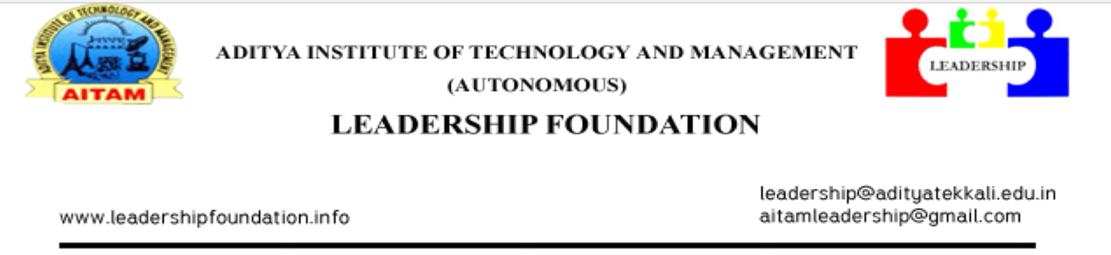

24-09-2015,
Tekkali.

CIRCULAR

We are happy to announce that our college is going to conduct Leadership Premier League (LPL) shortly. For that we request all the 2nd and 3rd year students of our college those who are interested in CRICKET should attend on 26th September 2015 i.e., on Saturday in our college ground for selections.

Note: Circulate to all II & III B.Tech Class Rooms
CC to ALL HOD’s

P.Sai Vijay,
CEO-LEADERSHIP FOUNDATION.

